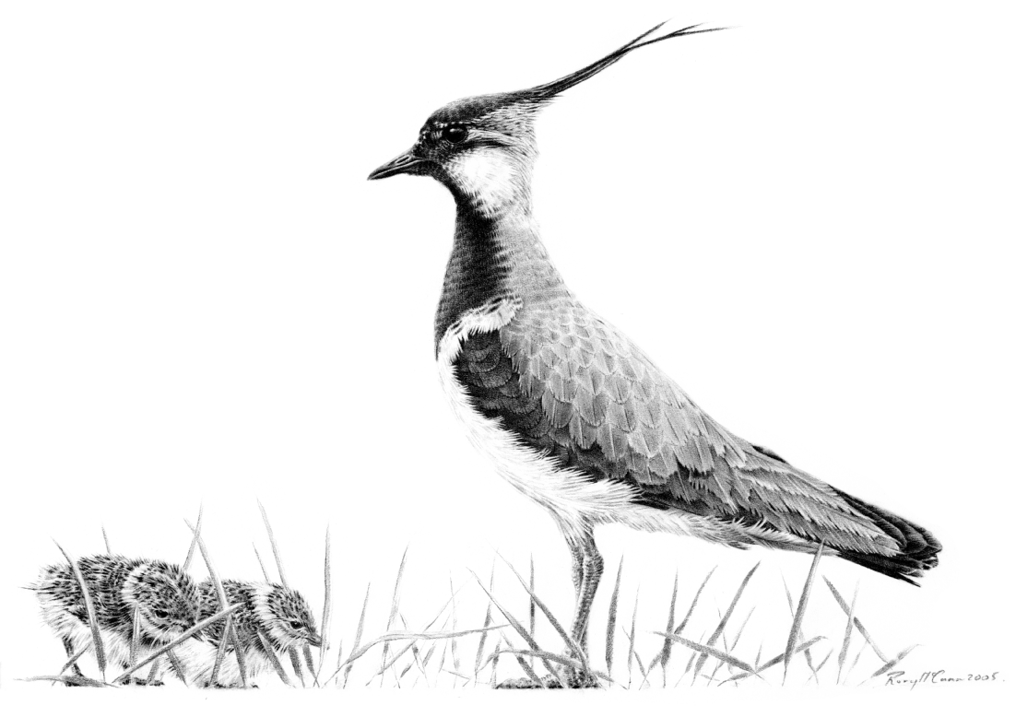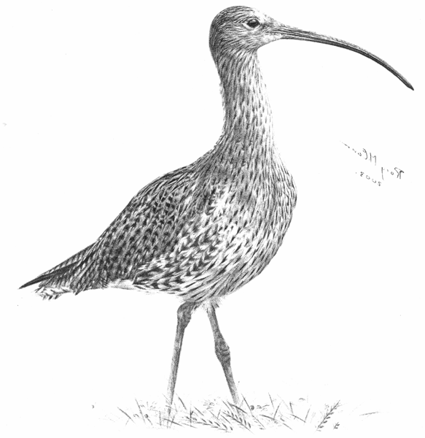
Upper Clun
Community Wildlife Group

PUBLIC MEETING

7.30 pm
Thursday, 20th November 2014
Newcastle Community Centre

Celebrating Wildlife in the Upper Clun
- Iconic species and Wildlife Sites
- HLS Agreements to safeguard the best habitats
- Mammals (Bats, Hedgehogs and other mammals)
John Mackintosh from Shropshire Mammal Group will talk
about their work, and how UCCWG can help

Results of 2014 Bird, Plant & Butterfly Surveys

Plans for Next Year
- How you can help / join in survey work
- Conservation of Target Species & Important Sites
- Bird, Wild Flower and Butterfly events for new members
- Mammal recording and events

Election of the Management Committee

Tea & Cakes
The Group is for everyone in the community, not just experts. Local people are shaping our work. We are gathering information on all kinds of popular wildlife, and working with farmers and landowners to safeguard it. We are working closely with, and have the support of, Land, Life and Livelihoods, the Clun & Bishop’s Castle Branch of the Shropshire Wildlife Trust, and the Shropshire Hills AONB Partnership.
For further information, contact the Secretary
Jacky Harrison, Reilth Top, Bishops Moat SY9 5LL (01588 630666).

Everyone Welcome!!
Please let us know if you are coming, so we can cater for you
Free Entry, but Donations Requested, Please. Raffle

Keep up to date via our website www.ShropsCWGs.org.uk

