***Community. .. ...***

***Wildlife. . Group. .. ...***

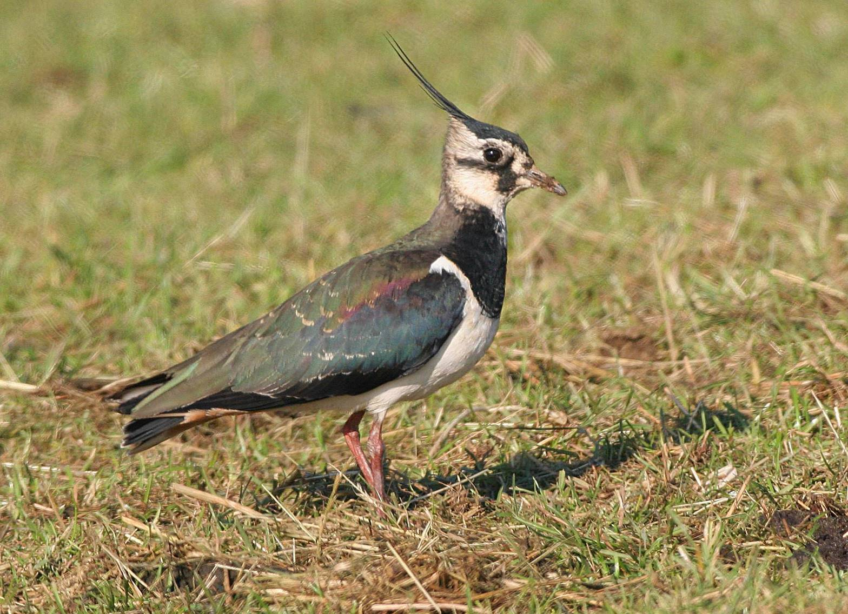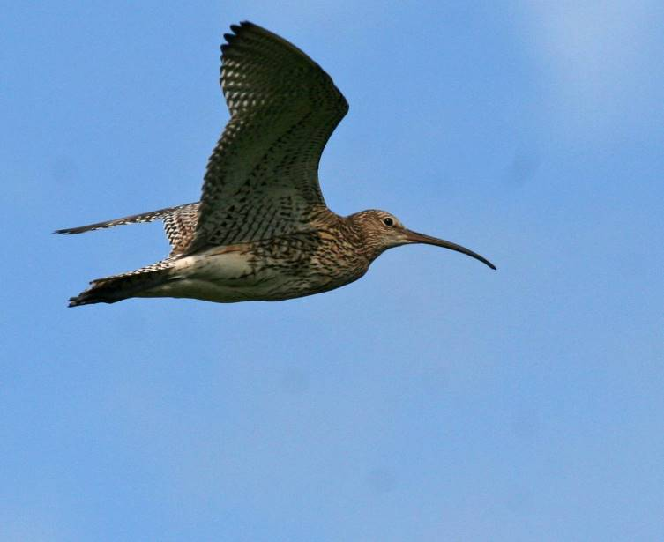

***Clee Hill***

***Curlews, Lapwings & Other Birds***

***Survey 2014***

**Curlews, Lapwings and Other Birds Survey**

**2014**

**CONTENTS**

Objectives 1

Methodology 1

Curlew 2

Lapwing 4

Other Target Species 6

Decline of Lapwing and Curlew 8

Recommendations 10

Use of Clee Hill CWG Survey Results 11

Barn Owl Nest Box Scheme 11

Bird Walks 12

Acknowledgements 12

Report 12

Summary 2014 13

Plans for 2015 13

**APPENDICES**

**Appendix 1. Map of Survey Area, showing Square Boundaries and Tetrad Codes 14**

**Appendix 2. Bird Survey - Outline Instructions 14**

**Appendix 3. Bird Survey Instructions on Survey Maps 15**

**Appendix 4. Bird Survey – Results from each of the Three Survey Periods 18**

**Appendix 5. References 20**

## Objectives

Bird Group members were asked to find out where Curlew and Lapwing occur in the breeding season, record behaviour indicative of breeding, and record other species, most of which are of nature conservation importance (i.e. they are Target Species for Natural England’s Environmental Stewardship Higher Level Scheme (HLS), are on the *Red List* or *Amber List* of *Birds of Conservation Concern* because they have suffered large declines in the last 25 or 50 years, and are Target Species in the UK Biodiversity Action Plan).

In addition to Lapwing and Curlew, the target species were:-

* Kestrel
* Red Kite
* Barn Owl
* Grey Partridge
* Snipe
* Skylark
* Meadow Pipit
* Cuckoo
* Dipper
* Swift (nest sites only)
* Yellow Wagtail
* Dunnock
* Stonechat
* Wheatear
* Spotted Flycatcher
* Tree Sparrow
* Linnet
* Bullfinch
* Yellowhammer
* Reed Bunting

This repeated similar surveys undertaken in 2012 and 2013, to monitor population trends for key species, as well as establish the current population and distribution.

## Methodology

The area covered by the Clee Hill Partnership was divided up into 20 tetrads (2x2 kilometre squares, made up of four of the one kilometre squares shown on Ordnance Survey maps). A map showing all these tetrads, with the Tetrad Reference code, is attached as Appendix 1. (The prefix SO (defining the 100 km square on the OS National Grid) has been omitted, as this is common to all the squares in the area).

People interested in helping were given a copy of the Outline Survey Instructions, attached as Appendix 2.

Those who agreed to help were allocated a square / tetrad, and requested to survey it once during each of three specified two week periods, around 1st April, 1st May and mid June.

* The first period follows the arrival of Lapwing and Curlew back on the breeding grounds. This is the best time to find breeding Lapwing (first egg date is usually around 1st April).
* The second period is the best time to find breeding Curlew (first egg date is usually around 30th April).
* The third period is timed to find any Curlews that have successfully hatched and still have chicks. It is also the best time to find the Other Target Species.

Members were provided with a large scale map of their tetrad for each of the three periods, to record observations, and requested to spend around three hours on each visit. The survey Instructions were printed on the back of the map. These instructions are attached as Appendix 3. Members were also asked to record target species just beyond the boundary of their tetrad.

Members were also requested to send in “Casual Records” of Lapwing and Curlew seen at any time in the rest of the area, and also any seen in their own tetrad(s) outside the periods when the three tetrad surveys were being carried out. Casual Record maps were provided for this purpose.

A feedback meeting was held on 30th May, to present the results of the first two surveys, discuss them, provide clarification where necessary, and iron out any difficulties experienced by the participants. Eleven survey participants attended.

For the first time, some survey work was carried out in all 20 tetrads, and members spent almost 190 hours on it (excluding the double time spent when couples or friends surveyed a square together). This represents an excellent effort, considerably better than 2013

A summary of the results was presented at a public meeting on 30th September, which also included a talk by Leo Smith on *The Return of the Red Kite to Shropshire*. Twenty-one people attended, and £81 was raised for Group funds.

## Curlew

The location of Curlews found during the surveys, or reported on Casual Record maps, is shown on page 4.

Analysis of the cluster of records in tetrads SO67D, E and I has been greatly helped by personal observations from local residents.

Forty-four records from the diary kept at Pot House Farm suggest one pair in square SO67I, with a different pair in SO67D (Angela and Kirsty Mackirdy, *pers.comm*.). A nest with four eggs was reported by the Chair of the Commoners, found on Magpie Hill (SO67D) on 7 June, and sufficiently far from Pot House to probably be a different pair. Other observations from Cleeton St. Mary (SO67E) indicate “two pairs above the village rather than the usual three, based on the activity seen”, and their behaviour suggests they managed to hatch young, though none were actually seen. (Tim Lee, *pers.comm*.).These observations in SO67E apparently do not overlap with the pairs in SO67D & I.

This analysis is supported by observations on the Bird Walk on 30 March, when two displaying birds were seen at the same time, one on each side of Cleeton, with another heard to the north. This cluster is therefore estimated at 4 - 5 pairs in 2014. It was estimated at 3 – 5 pairs last year, and 4 – 5 pairs in 2012.

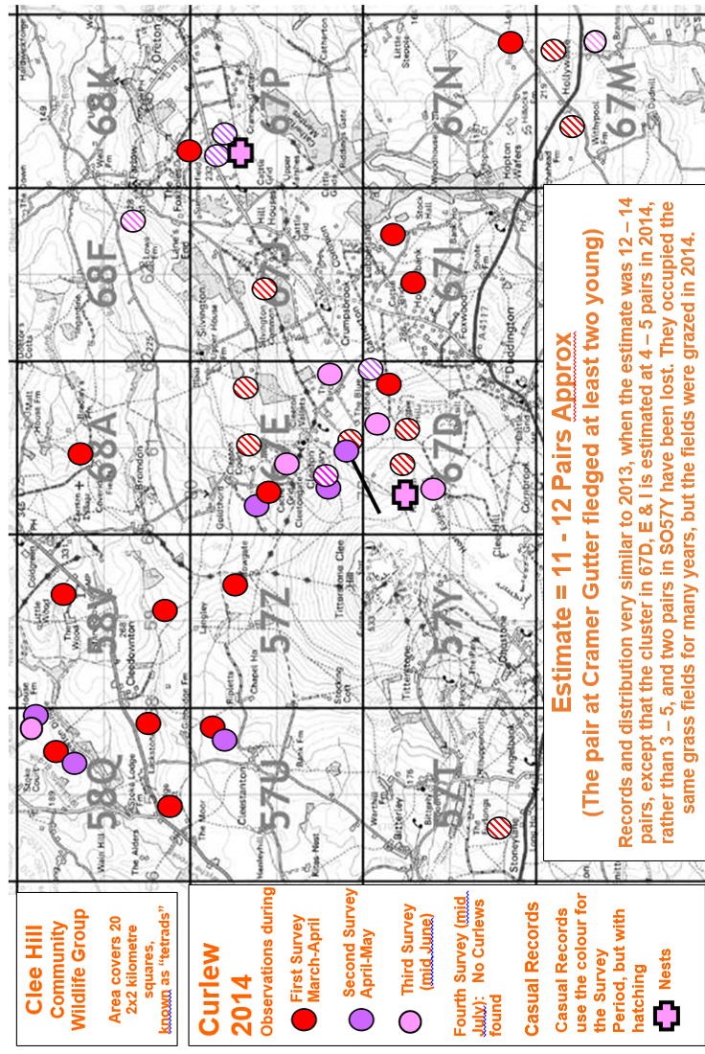

Apart from the cluster, the 2014 records and distribution were very similar to those in 2013, except that two pairs in SO57Y have been lost. They occupied the same grass fields for many years, but the fields were grazed in 2014 (Chris Neal, *pers.comm*.).

Little is known about the outcome of these breeding attempts, as the third survey, designed to see which Curlews have chicks, takes place around a month before any young birds are due to fledge. Breeding success was almost certainly very poor in 2012 and 2013 because of the bad weather during both breeding seasons (April – July). It is likely that breeding success was better this year, because of the warm spring. However, four pairs were still active during the third survey, indicating they had chicks, although the pair at Pot House farm were not heard after 12 June, and the pairs above Cleeton were “much quieter this year”, suggesting these three pairs all failed.

To try and obtain further information on outcome, members were asked to revisit their squares in mid-July if they had found Curlews in previous surveys. However, only four squares were visited in July, and no evidence of fledged young was observed. Indeed, no Curlews were recorded at all.

Other casual observations strongly suggest that the pair near Cramer Gutter (67P) fledged at least two young.

A single bird recorded in 2014, and the two previous years, in SO57T suggests this is part of an additional territory, probably centred in SO57N. Observations in future years may clarify this.

A pair found in SO68K in 2012 was only seen a bit further north, outside the area, in SO68L, in 2013. They were not recorded in 2014.In relation to this site the 2012 report stated that “A pair are believed to have been breeding close to this location, near Stoddeston (in SO68L), for some years (Chris Bargman, *pers.comm.).”* This pair has not been included in the population estimate for the area in either 2012 or 2013.

Another pair just outside the area in SO68B was present in all three years.

**From the above observations and analysis, it is estimated that the Curlew population in the area is currently 11 – 12 breeding pairs, with another two pairs again located in adjacent tetrads (SO57T and SO 68B). A third pair, seen in SO68L in 2012 and 2013, was not recorded in 2014.**

**Last year’s report estimated 12 – 14 breeding pairs in 2013,**

**and 10 – 11 pairs in 2012.**

## Lapwing

The location of Lapwings found during the surveys is shown on page 5.. Again, the observations are described in detail in the Bird Survey Report.

Only two pairs were found, both together in 67M, where a sitting bird was found last year.

**From the observations and analysis, it is estimated that the Lapwing population in the area is currently only 2 breeding pairs. This compares with 1-2 pairs last year, and 3 pairs in 2012.**

The outcome of the nests in 67M is not known.

Pairs found in SO57U and SO68K in 2012 were not relocated in 2013 or 2014.

Curlews. This reinforces the similar anecdotal evidence collected in the previous two years, and quoted in the relevant report.

## Anecdotal Evidence for the Decline of Lapwing and Curlew

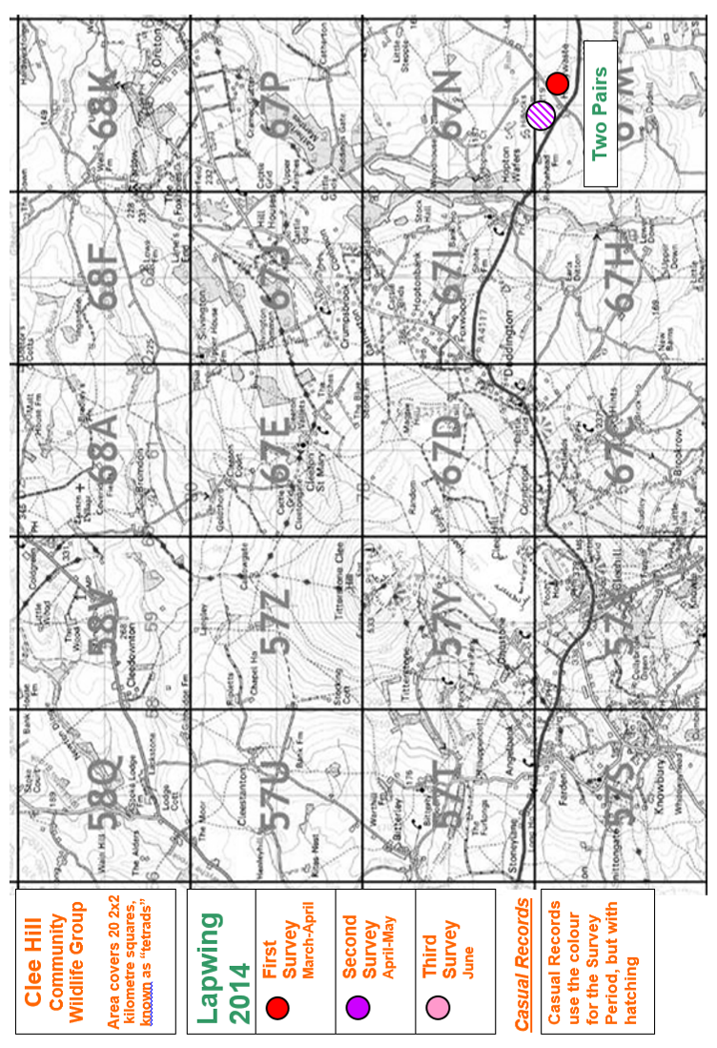

Members of the Bird Group who live in the area, and other local residents, say that Lapwings and Curlews are less common now than they used to be. Some members talked to local farmers in the course of their surveys, and they too said that Lapwings and Curlew are less common now than they used to be. Lapwings have apparently declined much more than Curlews. No specific examples of anecdotal evidence were collected in 2014, but several specific examples were quoted in the 2012 and 2013 reports.

## Other Target Species

The numbers of the Other Target Species recorded during each of the three survey periods are listed in the Tables in Appendix 4. They are summarised in Table 1 on page 7

**Table 1. Other Target Species - Summary**



Note that members were asked to record individual birds, not pairs (so at some locations both the birds in the pair were recorded, and in the final survey some recently fledged juveniles may have been recorded as well). Numbers of Meadow Pipit, Linnet and Yellowhammer may be exaggerated by the presence of winter flocks moving onto the breeding grounds, before dispersing to the individual breeding sites, during the first two surveys.

The summary table shows the maximum count for each species in each tetrad. This may under-record some species, but the alternative – adding all the counts together – would lead to considerable double or triple counting of some individual birds.

As expected in a survey of this type, the expertise of members, and the time they had available to undertake the surveys, varied considerably. The survey squares also vary

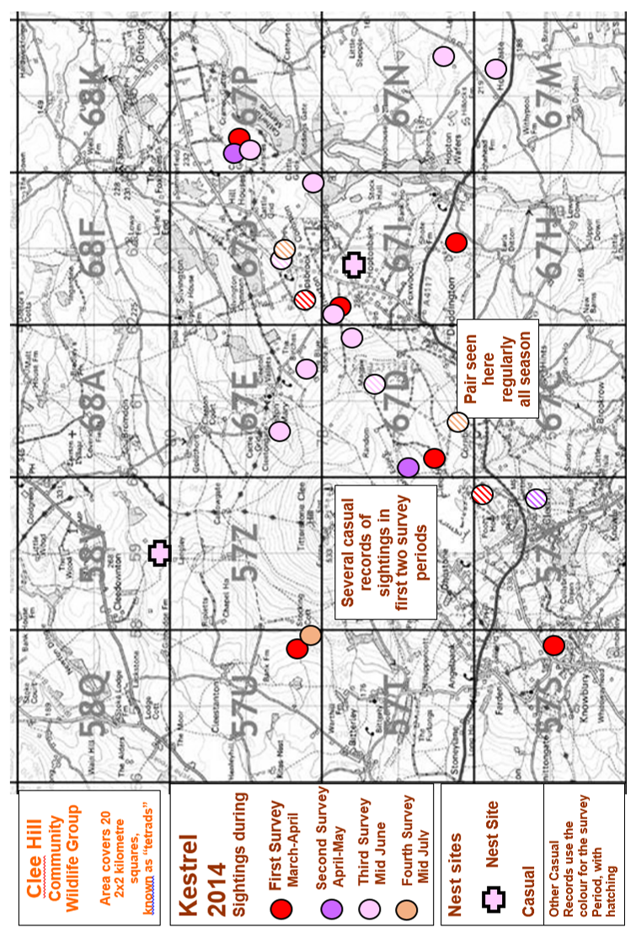

considerably, in accessibility and terrain. The “detectability” of the birds themselves also varies considerably, according to prevailing weather conditions, time of day, stage in the breeding cycle, and the normal behaviour of each species. Thus the survey results will give an indication of the species present, but only a very small proportion will have been recorded.

It will be seen that Skylark, Dunnock and Yellowhammer are widespread and numerous, Meadow Pipit are numerous in restricted parts of the area where suitable habitat still exists (the Commons), and the remaining species that were found are present only in their specific habitats, and in small numbers.

Kestrels are conspicuous, and forage over large areas, so an assessment can be made of their population. The records from 2014 are shown in the map on page 7.

Four young fledged from the nest near Pot house Farm in SO67I (Angela & Kirsty MacKirdy, *pers.comm*.), and the nest in SO57Z was occupied again.

There were more sightings this year, as the weather was considerably warmer. The analysis last year gave an estimate of seven pairs of Kestrel. This year birds were seen at the same places, but also at some new locations, suggesting perhaps nine pairs in 2014.

Cuckoo was recorded more this year than last year, but in similar locations. They range far and wide, but they were heard persistently on Magpie Hill and Catherton Common, so there might be two breeding pairs, rather than one pair, believed to be the number in 2012 & 2013.

Red Kites were seen in five tetrads, one more than last year, including two young birds together on the first Bird Walk. There was no evidence of breeding. There was a report of a pair of Kites going in and out of a wood throughout the 2013 breeding season, suggesting an active nest in the area, but it was received too late to check. Such a nest would be the most easterly found in Shropshire since successful breeding recommenced in 2006 following a gap of 130 years. However, the pair did not return to this site in 2014.

Snipe were seen in three tetrads on the first survey in early April, and were almost certainly passage birds. It is unlikely any still breed in the area. Grey Partridge were unexpected, but they have been seen in all three years in different tetrads, but it is believed that captive bred birds have been released in the area by the Burwarton shoot (Eric Davis, *pers.comm*.).

Not surprisingly, three of the more scarce Target Species were not recorded at all during the surveys – Barn Owl, Yellow Wagtail, or Tree Sparrow. However, a Barn Owl was reported in 68K.

Two other Target Species are not shown in the Table. A pair of Dippers was seen 67C, and Swift nest sites were found in 68A and 68K.

A used Dipper nest was subsequently found in SO67C, and another pair raised young near Silvington (67J) (Jon Lingard, *pers.comm*.).

## Decline of Lapwing and Curlew

Lapwing and Curlew are in decline, nationally, here, and elsewhere in Shropshire. The decline in the Clee Hill area is shown graphically in Figure 1. This compares the distribution maps representing the results of the current survey in 20 tetrads with the relevant parts of the maps shown in *An Atlas of the Breeding Birds of Shropshire*, based on six years fieldwork 1985-90, and published in 1992. Both maps have been compiled on the same basis and it is likely that more fieldwork has taken place in the current period, so the decline is undoubtedly real.

**Figure 1. Distribution of Curlew and Lapwing in the Clee Hill area: Comparison between 1985-90 and 2008 – 13**

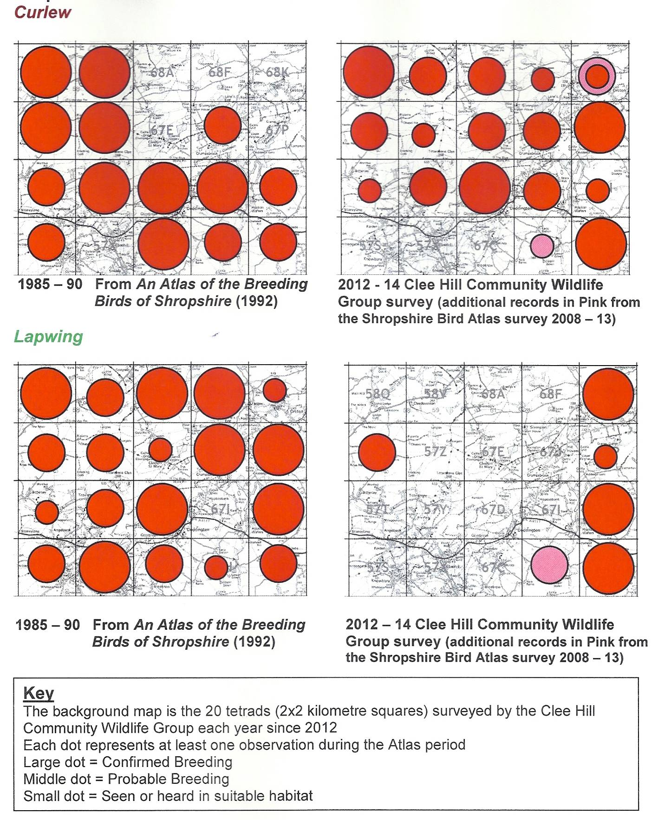

A large dot indicates that breeding was proved in the tetrad (usually a nest was found, or a bird was seen incubating, or dependent young were seen), a middle size dot indicates probable breeding (usually a pair was seen, or territorial behaviour was observed), and a small dot indicates possible breeding (a bird was seen or heard in the breeding season).

Such an observation needs to occur at least (but perhaps only) once in the whole Atlas / survey period, and it gives no indication of the number of breeding pairs. These distribution maps therefore probably overestimate the population:-

* Lapwings have specific nesting habitat requirements, which in this area usually mean they nest on arable fields planted with spring crops, which get moved each year by crop rotation on farms. Therefore one pair, or a small colony, may breed in several different tetrads over a period of years.
* A pair of Curlews may also move their nest from place to place within their large territories, so again one pair may nest in several tetrads in the Atlas period. Nests are difficult to find, but pairs and territorial display are relatively easy to find, but may be observed anywhere within the large territory, so one pair may be recorded in several tetrads.

Even so, it is clear from the distribution maps in Figure 1 that both species are much less widespread here than they were 20 – 25 years ago.

Action to attempt to reverse these declines is being taken. Both species have been designated as UK Biodiversity Priority Species by the Government, as part of its commitment to international biodiversity targets, precisely because of the rapid decline.

Both species nest on farmland, and the Environmental Stewardship Higher Level Scheme (part of the system of payments to farmers through the Common Agricultural Policy of the European Union) included provision to reward farmers for sensitive management of habitat on their farms, and providing other environmental benefits. Farmers applying to join the scheme had to take into account the breeding habitat requirements of a number of birds, including Lapwing and Curlew, if they breed on or near the farm, or use land there for feeding. HLS includes specific prescriptions, and payments, for Lapwing and Curlew habitat, if the farmer wants to take them up.

The data provided by Community Wildlife Groups, on the location and habitat of these priority species, helped Natural England (the Government Agency responsible both for achieving the Biodiversity targets, and administering the Environmental Stewardship Scheme) to target its limited resources more effectively to achieve this objective.

At least two farms were able to join HLS as a result of the Group’s survey results.

HLS has now come to an end, and is being replaced by a new Scheme, Countryside Stewardship, part of the EU Common Agricultural Policy for 2015 - 22, with similar objectives. However, it is intended to focus the new scheme more, to help achieve the Government’s Biodiversity 2020 targets, and overcome the fragmentation of habitats that has led to so much of the decline of wildlife.

The details are still being worked out, and Targeting Statements and Criteria are currently being drafted. New applications will be invited during 2015.

## Recommendations

***Natural England is recommended to encourage farmers with breeding Lapwing or Curlew , on or near their land, to join***

***the Countryside Stewardship Scheme,***

***utilising the appropriate options to maintain and***

***enhance the habitat for these priority species***

## Use of Clee Hill CWG Survey Results

Most importantly, the Clee Hill CWG survey results are made available to Natural England. They show the importance of particular areas for these species, which will hopefully encourage farmers to manage their land more sensitively, and provide Natural England with objective evidence to judge individual farm applications to join NELMS, and information to target the use of their limited resources more effectively.

The results also reinforce and supplement the results from other Community Wildlife Groups operating in the Shropshire Hills, which together now cover well over 500 square kilometres, around two-thirds of the Shropshire Hills AONB. These results help inform the AONB Management Plan, which has recently been revised to cover the five years 2014 – 19.

The records at tetrad level have also been supplied to Shropshire Ornithological Society for incorporation into the Shropshire Bird Atlas. The Atlas project has now completed its six years fieldwork 2008-13, and results should be published in a new county Avifauna, *The Birds of Shropshire*, around the end of 2015.

Comparison of the Atlas maps from the current project with those from the 1985 – 90 Atlas, for the whole of Shropshire, show that Curlew, Lapwing and Kestrel are all declining rapidly. Our survey results show that Curlew and Kestrel are still well established here, and this area is therefore very important to them. Providing this information to the Clee Hill Partnership strengthens the bid to the Heritage Lottery Fund for a project to conserve and enhance the natural and cultural heritage of the Clee Hill area

Coupled with the results of other surveys, the results may also contribute to the identification of potential new County Wildlife Sites. These sites are monitored by Shropshire Wildlife Trust, which encourages the landowners to manage the sites sensitively, so they retain their value for wildlife.

## Barn Owl Nest Box Scheme

The Bird Group initiated a Barn Owl nest box scheme in the area in 2013.

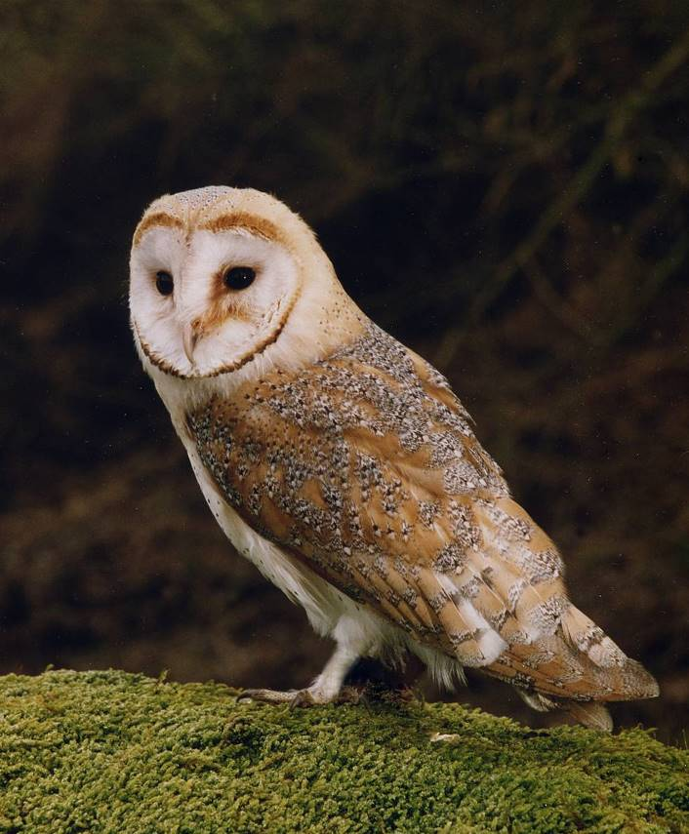

Barn Owl is on the *Amber List* of *Birds of Conservation Concern 3 (2009),* because of a long term population decline caused by loss of foraging habitat and nest sites. Provision of nest boxes will help reverse this decline locally. Nest boxes are more likely to be used, and help increase the population, if they are put near to existing Barn Owl territories and foraging areas.

These specially designed nest boxes can be provided free of charge to farmers and landowners with suitable habitat in the Clee Hill area. This requires-

* An isolated farm building, or large isolated tree or pole more than 400 metres from nearest woodland

**© John** **Harding**

* Four hectares (10 acres) of permanent rough grassland nearby, several inches tall to provide cover for voles and other prey

A poster advertising the scheme has been put up around the area. Several landowners have responded and potential sites have been assessed by Chris Bargman and Anton Schooley, together with John Lightfoot from the Shropshire Barn Owl Group. Four or five boxes should be put up in the near future, in time for potential use in 2015.

***If you see a Barn Owl, we’d like to know, please***

***For further information, or to report a Barn Owl sighting in the Clee Hill area, please contact Chris Bargman 01299 270514*** [***helpbarnowls@gmail.com***](mailto:helpbarnowls@gmail.com)

## Bird Walks

Three walks were held, for members and the general public

1. Sunday 30 March, starting at Cleeton St Mary, and visiting the Common up to Magpie Hill. This walk also provided practical training for people who wanted to help with the Bird Survey
2. Saturday 10 May at The Novers woodland, specifically to learn about identifying birds by their song (Joint Meeting with Clee Hill Heritage Trust)
3. Sunday 8 June starting at the Quarry Tea Rooms, and visiting the other side of the Common up to Magpie Hill

A wide variety of birds were seen, and the walks averaged around 8 participants each.

## Acknowledgements

Most importantly, thanks to the Group members who undertook the survey work:-

Chris Bargman

Hazel Bows

Bob Braddock

Beth & Lionel Bridge

Titch Carter

Julie Cooke

Eric Davies

Eric Evans

Gill and Chris Eyre

Jane Foster

Andrew Heideman

John & Pauline MacIntosh

Kirsty & Angela Mackirdy

Jim Martin

Nina Mills

Chris Neal

Julie Price

Peta Sams

Gareth Thomas

Margaret & Graham Thompson

Marian Wootton

Thanks also to:-

* Chris Bargman and Anton Schooley, for organising the Barn Owl nest box scheme
* John Lightfoot, of the Shropshire Barn Owl Group, for help and advice
* Tim Lee and Jonathon Lingard for additional records and information.
* John Tucker, for leading the Bird Walk at The Novers
* Matt Cotterill of Natural England, who provided the survey maps.

## Report

A copy of this report has been supplied to all people who contributed to the surveys, or supplied additional records, and to Natural England.

Copies can be downloaded from the Clee Hill part of the Shropshire Community Wildlife Groups website, www.ShropsCWGs.org.uk

Alternatively, copies are available (electronic .pdf versions or paper copies) from Leo Smith, The Bryn, Castle Hill, All Stretton, Shropshire SY6 6JP. Phone: 01694 720296 email leo@leosmith.org.uk.

## Summary 2014

*This report summarises a successful third year for the Bird Group. Members showed a high level of commitment in carrying out the surveys.*

*For the first time all 20 tetrads were surveyed to some extent, and we now have an even better understanding of the population and distribution of Lapwing and Curlew, and the status of the Other Target Species. This is valuable information for the conservation of these birds. Further survey work in future years will add to this baseline, and establish population trends in the area.*

*Three Bird Walks were held, 21 people came to a talk on “Return of the Red Kite to Shropshire”, and the Barn Owl nest box scheme was developed.*

## Plans for 2015

The Bird Group intends to repeat the Bird Survey next year. New participants are needed, so we hope to recruit new members.

The Barn Owl nest box scheme will be developed, and a programme of local bird walks and other activities will be held.

Further consideration will be given to these plans, and any other proposals people want to make, at the Group public meeting on 25th November,

A Bird Group meeting will be held prior to the next breeding season, to plan the survey, allocate survey squares to participants, and arrange and publicise the other activities.

Everyone interested in birds is welcome at all meetings and events. A Programme will be published after the public meeting. Details can also be found and downloaded from the Clee Hill part of the joint website for all the Community Wildlife Groups in the Shropshire Hills, www.ShropsCWGs.org.uk

Leo Smith

November 2014

### Appendix 1. Map of Survey Area, showing Square Boundaries and Tetrad Codes

The prefix SO (defining the 100 km square on the OS National Grid) has been omitted, as this is common to all the squares in the area.

### Appendix 2. Bird Survey - Outline Instructions

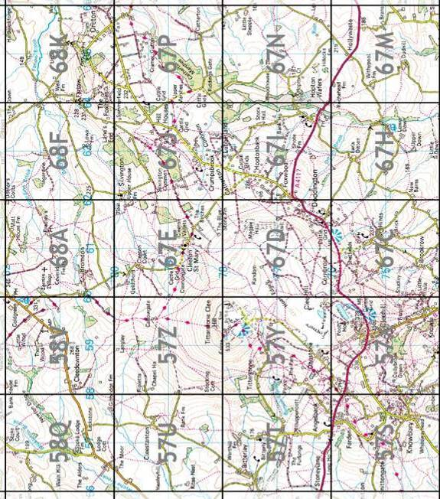

### Appendix 3. Bird Survey Instructions on Survey Maps

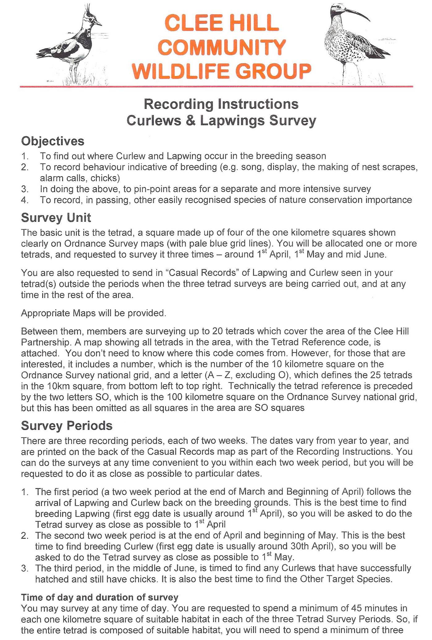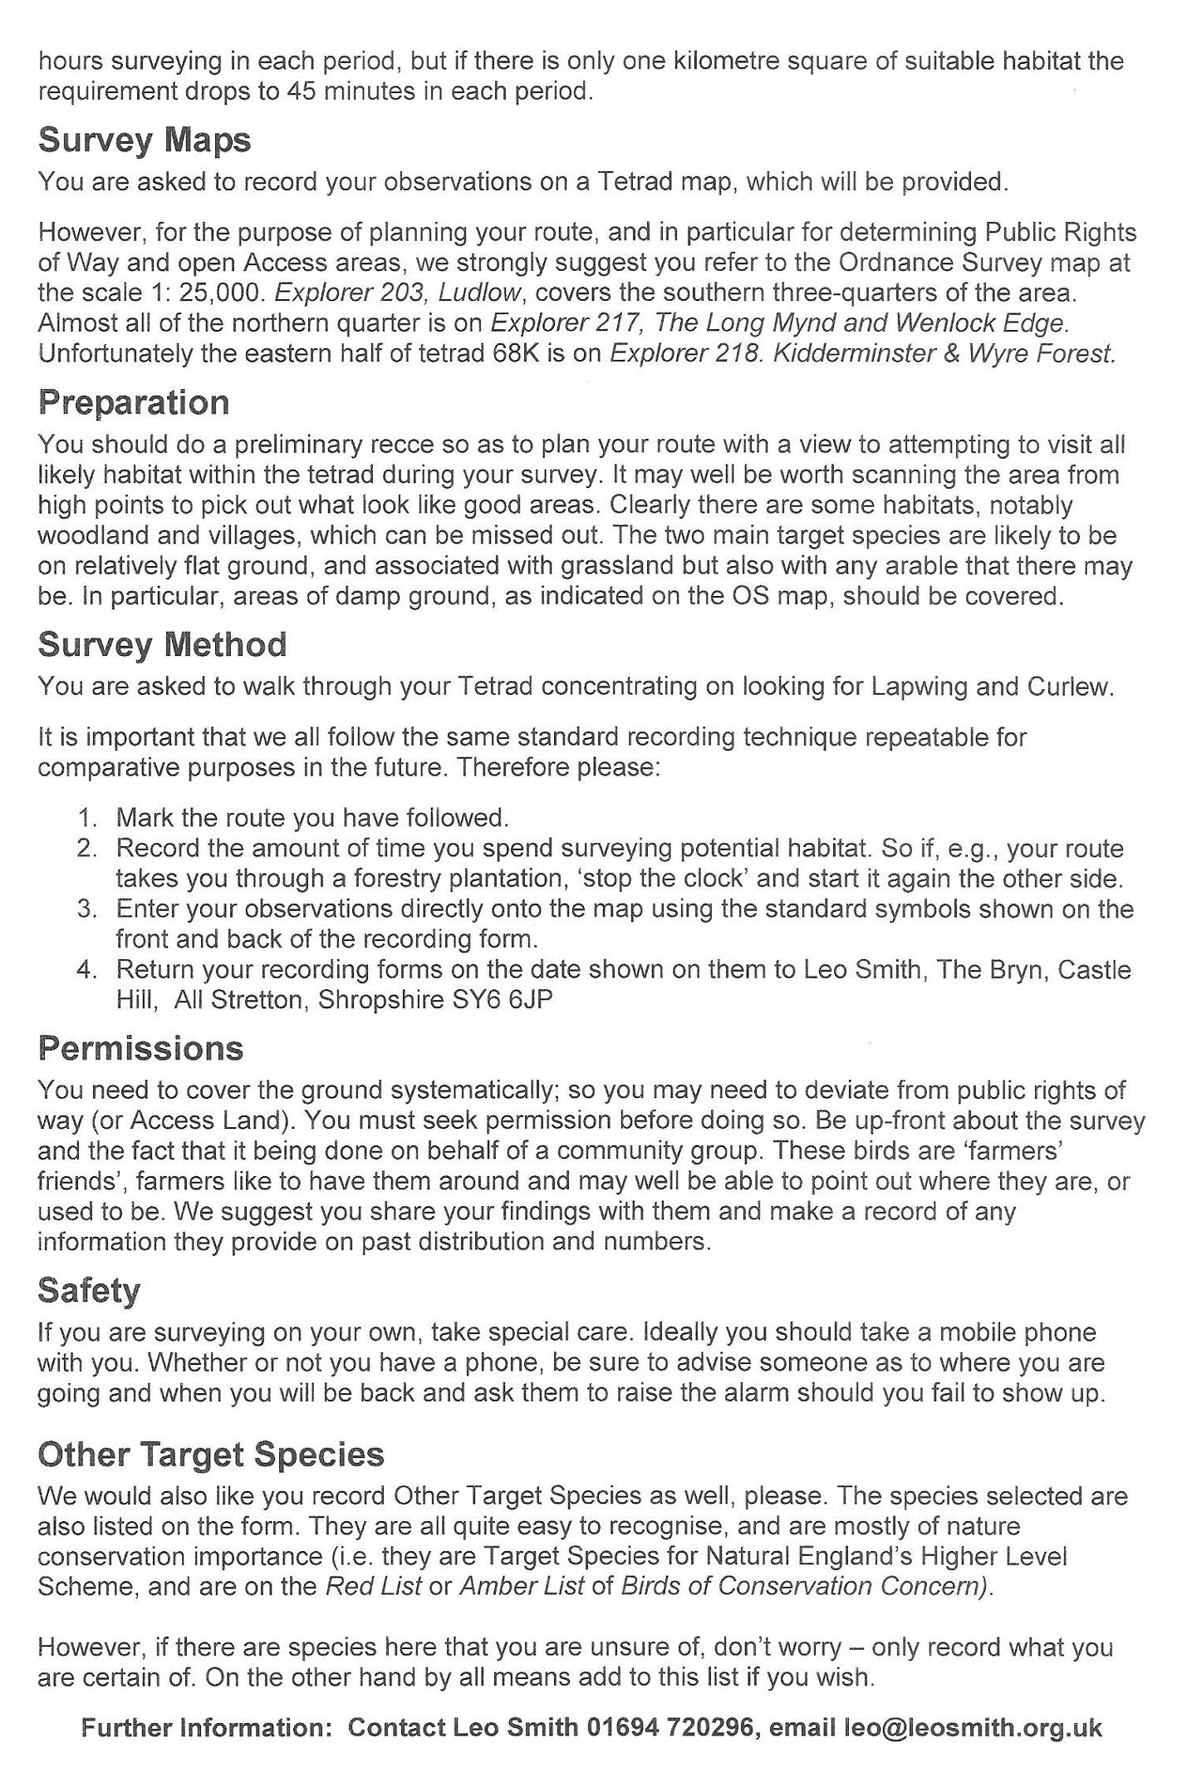

### 

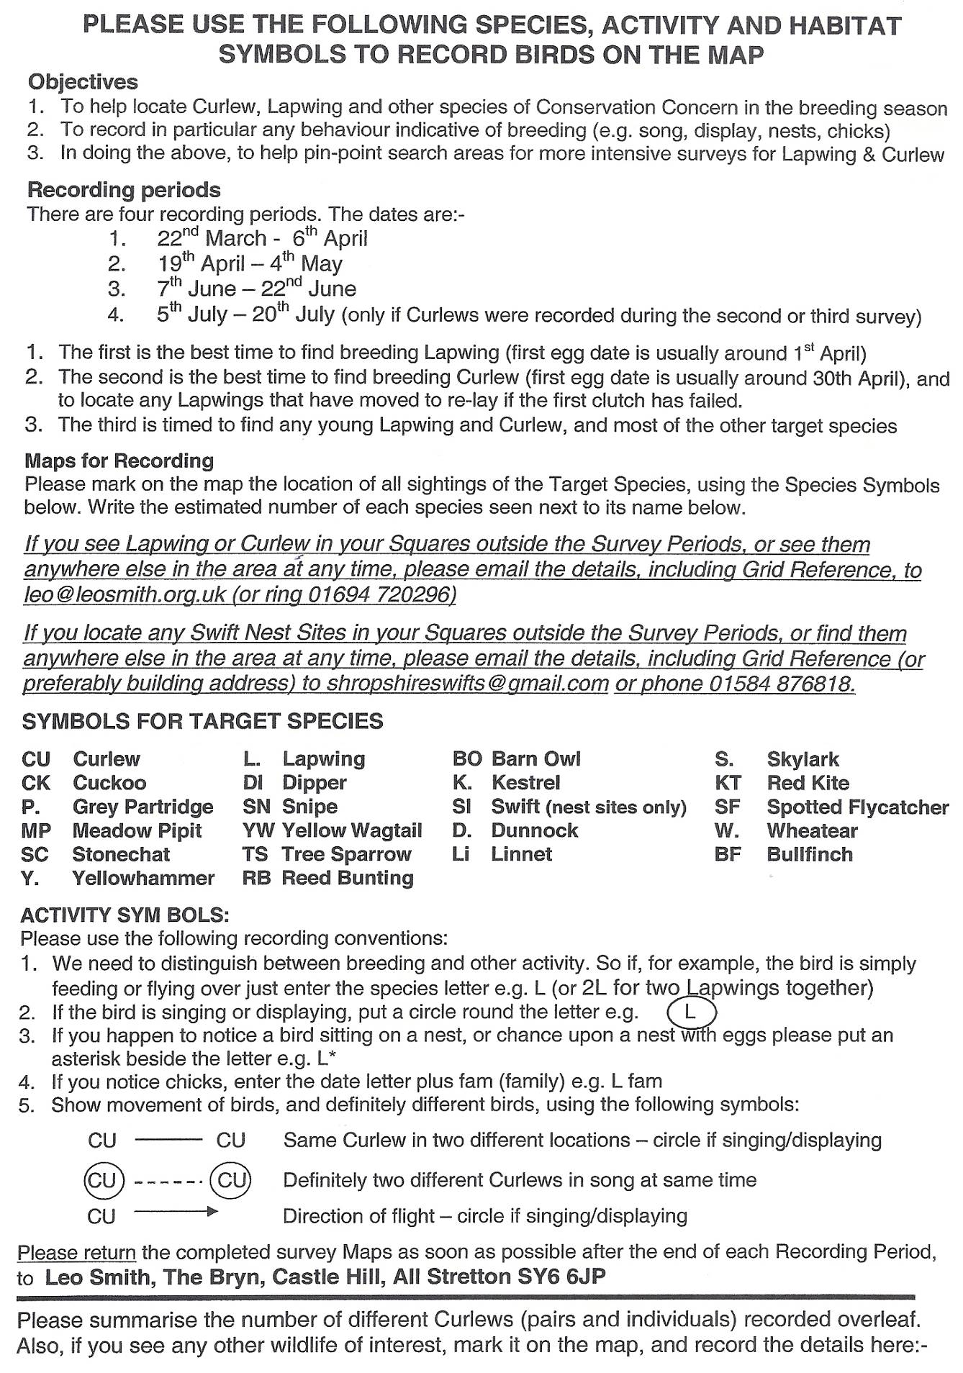

### Appendix 4. Bird Survey – Results from each of the Three Survey Periods



### **Appendix 5. References**

Bibby, C. J., Burgess, N. D., Hill, D. A., & Mustoe, S. H., *Bird Census Techniques (Second Edition)*,Academic Press Ltd., London (2000).

Deans, P., Sankey, J., Smith, L., Tucker, J., Whittles, C., & Wright, C. 1992. *An*

*Atlas of the Breeding Birds of Shropshire.* The Shropshire Ornithological Society.

Grant, M.C., Orsman, C., Easton, J., Lodge, C., Smith, M., Thompson, G., Rodwell, S. & Moore, N. 1999. *Breeding success and causes of breeding failure of Curlew* Numenius arquata *in Northern Ireland.* Journal Of Applied Ecology, 36: 59- 74.

Sheldon, R.D. 2002a *Lapwings in Britain – a new approach to their conservation* British Wildlife, December 2002: 109-115

Sheldon, R.D. 2002b *The breeding success and chick survival of Lapwing* Vanellus vanellus *in arable landscapes, with reference to The Arable Stewardship Pilot Scheme.* Unpublished PhD Thesis, Harper Adams University College

Shrubb, M. *The Lapwing* T & AD Poyser 2007

Sim, I.M.W., Gregory, R.D., Hancock, M.H., & Brown, A.F. *Recent changes in the abundance of British upland breeding birds* Bird Study, 52: 261-275

Wilson, A.M., Vickery, J.A., Brown, A., Langston, R.H.W., Smallshire, D., Wotton, S. & Vanhinsbergh, D. 2005. *Changes in the numbers of breeding waders on lowland wet grasslands in England and Wales between 1982 and 2002*. Bird Study, 51: 55-69

Smith, L*. Lapwing, Curlew, & Other Wildlife in the Upper Onny Valley (Upper Onny Wildlife Group Survey Results & Report* Annually since 2004

Smith, L. *Lapwing & Curlew in the Clun Environmentally Area* Survey Report *2006.*

Smith, L*. Upper Clun Community Wildlife Group**Report* Annually since 2007

Smith, L. *Kemp Valley Lapwing Project* Annually since 2009

Smith, L. *Kemp Valley Community Wildlife Group Report*  Annually since 2011