St. Micheal’s and All Angels, All Stretton SO462958
A Wildlife Survey by Strettons Area Community Wildlife Group (SACWG)
Report by Caroline Uff
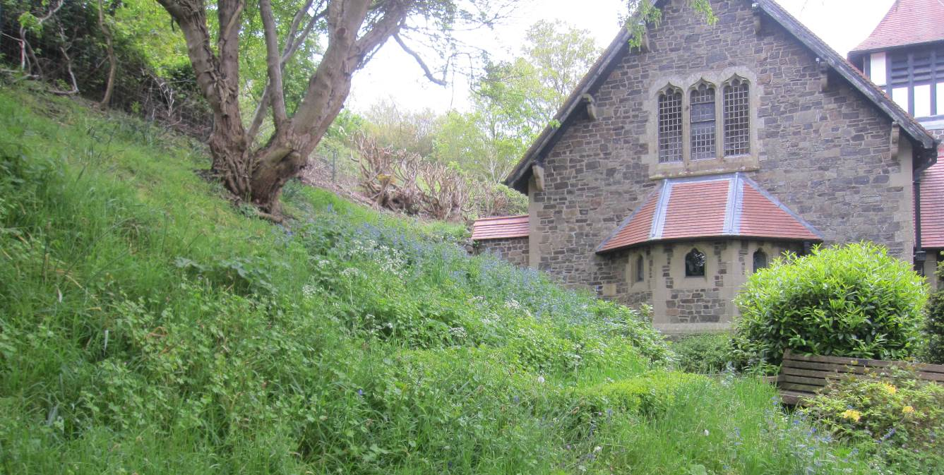
Image: C.Uff
Introduction
St Michael’s and All Angels is situated on the edge of All Stretton. It is bounded on the south side by the Shrewsbury Road and to the north by the Long Mynd SSSI. It is quite shady and mostly on steep ground with exposed rock behind the church. A previous survey of the churchyard was carried out in 1998 by J.Thompson.
Survey details
On 17/5/2014 members of SACWG assessed the site.
Ground Flora: Species were recorded from a general walkover. Ferns were also identified.
Trees: The existing map from 1998 was checked and updated if necessary.
Mammals: A baited hedgehog tunnel was left for two nights to collect mammal footprints. Tracks and signs of other mammals were also recorded. Bats were not assessed.
Birds: Any birds seen or heard within churchyard were recorded. Those seen in flight were only recorded if it seemed likely they were using the site. Signs of nesting were noted.
Invertebrates: Any species encountered within the churchyard were identified as far as possible. Seep nets and beating trays were used.
Reptile mats: Two mats (felt roofing tiles) were left in situ for approx. 1 month around the period of the visit to act as refuges for reptiles.
Results and comments
In all 90 species were recorded and summarised below – the full list is given at the end.
 | # Species recorded | Comments
Ground Flora | 44 | Little change since 1998. The grassland here is of no special importance, but the flora includes some nice spring woodland species such as bluebell and primrose as well as cuckoo flower, food plant of the orange tip butterfly. The bare rock has good amounts of the aptly named navelwort.
Trees | 11 | Trees recorded in 1998 were still present. Old laburnum rich hedges are a feature of local interest. Despite its poisonous nature many hedges were planted with laburnum about 150 years ago in south- west Shropshire and parts of Wales, but the reason is open to debate.
Birds | 11
Invertebrates | 22 | Of particular note was the striking soldier beetle, Cantharis obscura. It is rare in Britain, designated ‘Nationally Scarce’ and has its stronghold in the Lake District as it favours wooded hillsides. However several recent records, including this, have confirmed that there is also a population in the Shropshire Hills.
Mammals | 1 | Mouse and cat footprints were picked up together in the mammal tunnel!
Reptiles | 1 | A slow worm was found. These shy and increasingly uncommon reptiles are in fact legless lizards rather than snakes. They do however often find a welcome refuge in churchyards. They are a legally protected species.

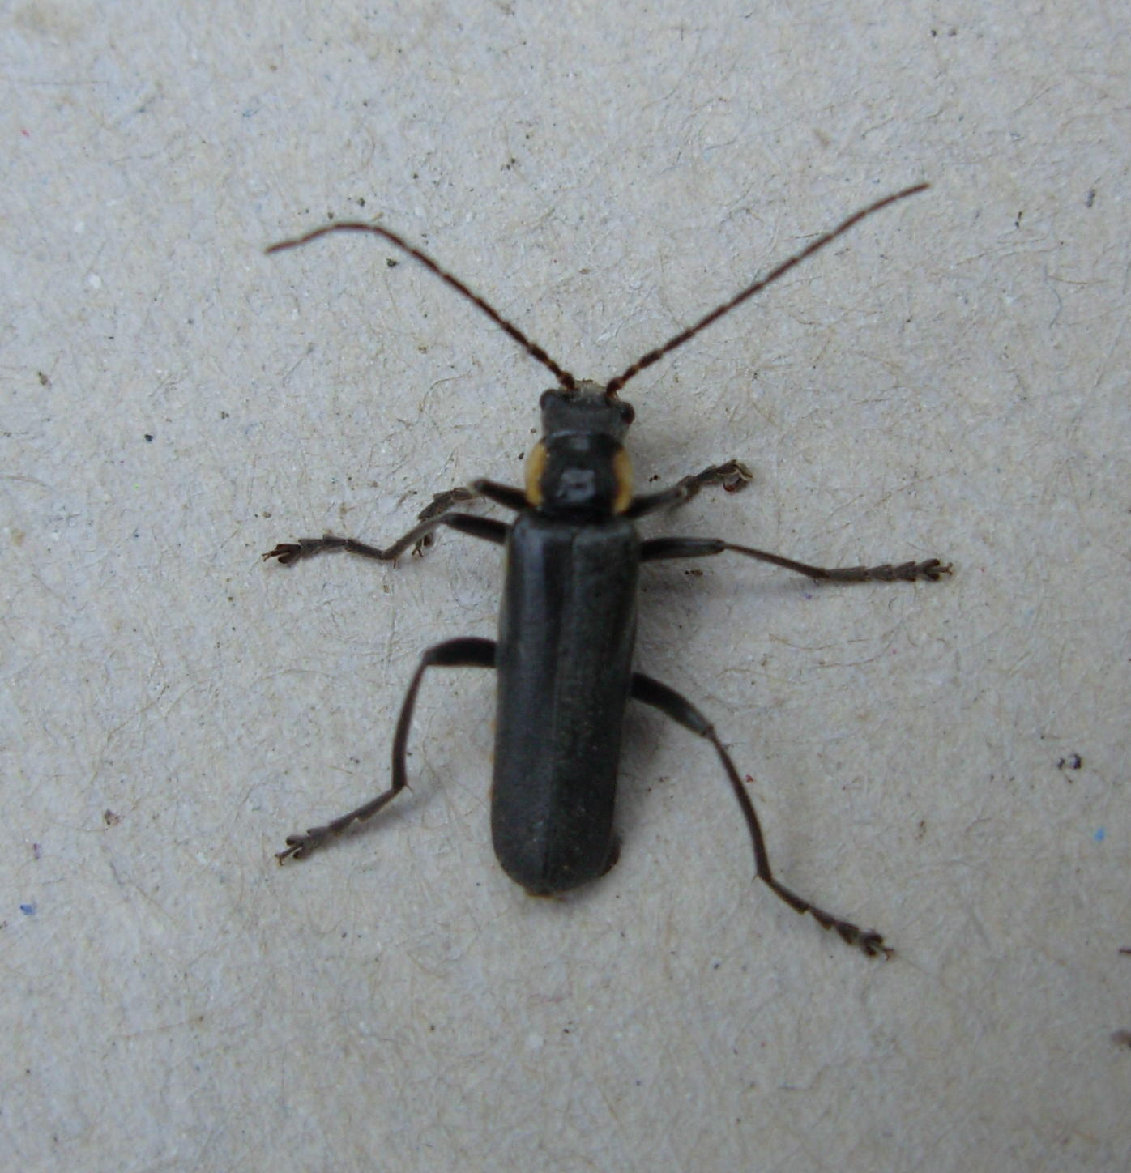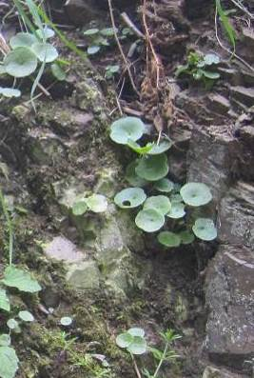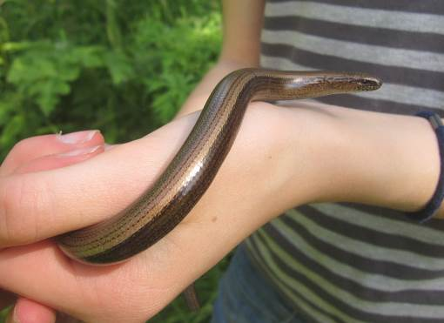

Image: C.Uff
Navelwort growing on the rocks (left)
Slow worm (above) and the soldier beetle Cantharis obscura (right) were worthy of note.

Image: C.Uff
Image: G.Wenman
The following sketch map by John Thompson in 1998 is still a good representation of the plants in the churchyard and the management suggestions in John’s report remain relevant today. The hedge along the eastern boundary is difficult to manage using traditional methods such as laying, but it may be possible to coppice and gap up if desired.
Plants recorded 2014 (English names used where possible)
Group | Plant name
Flowers | Alkanet, green
Flowers | Bluebell
Flowers | Bramble
Flowers | Buttercup, bulbous
Flowers | Buttercup, creeping
Flowers | Celandine, greater
Flowers | Celandine, lesser
Flowers | Cleavers
Flowers | Chickweed, common
Flowers | Crane's-bill, shining
Flowers | Dandelions
Flowers | Field speedwell
Flowers | Field/wood forget-me-not
Flowers | Foxglove
Flowers | Garlic mustard
Flowers | Herb-Robert
Flowers | Himalayan Balsam
Flowers | Hogweed
Flowers | Ivy
Flowers | Lady's smock
Flowers | Lamb's Lettuce
Flowers | Lord's-and-ladies
Flowers | Navelwort
Flowers | Nipplewort
Flowers | Primrose
Flowers | Ragwort
Flowers | Ramsons
Flowers | Speedwell, slender
Flowers | Solomon's seal
Flowers | Sorrel, common
Flowers | Speedwell, germander
Flowers | Stinging nettle
Flowers | Stitchwort, lesser
Flowers | Strawberry, barren
Flowers | Tutsan

Group | Plant name
Flowers | Vetch, common
Flowers | Wavy bittercress
Flowers | Wild strawberry
Flowers | Willowherb, rosebay
Flowers | Wood avens
Flowers | Wood sage
Ferns | Buckler-fern, broad
Ferns | Male fern
Trees and Shrubs | Ash
Trees and Shrubs | Crab Apple
Trees and Shrubs | Deodar
Trees and Shrubs | Holly
Trees and Shrubs | Laburnum
Trees and Shrubs | Laurel, Cherry
Trees and Shrubs | Lilac
Trees and Shrubs | Oak
Trees and Shrubs | Ornamental cherry
Trees and Shrubs | Rowan
Trees and Shrubs | Yew

Animals recorded 2014 (English names used where possible)

Group | Animal name
Bird | Blackbird
Bird | Blue tit
Bird | Carrion crow
Bird | Chaffinch
Bird | Collared Dove
Bird | Goldfinch
Bird | Great tit
Bird | Robin
Bird | Stock Dove
Bird | Wood pigeon
Bird | Wren
Mammal | mouse/vole
Reptile | Slowworm
Coleoptera (Beetles) | ladybird, 7-spot
Coleoptera (Beetles) | soldier beetle, Cantharis cryptica
Coleoptera (Beetles) | soldier beetle, Cantharis obscura
Hemiptera (bugs) | Shieldbug, green
Hymenoptera (Ants, bees and wasps) | mason bee, Osmia laeiania
Hymenoptera (Ants, bees and wasps) | ant, Myrmica rubra
Hymenoptera (Ants, bees and wasps) | bumblebee, buff-tailed
Hymenoptera (Ants, bees and wasps) | Honey Bee
Hymenoptera (Ants, bees and wasps) | mason bee, Osmia bicornis
Hymenoptera (Ants, bees and wasps) | bumblebee, white-tailed
Lepidoptera (Butterflies and moths) | micromoth, Adela reamuealla
Lepidoptera (Butterflies and moths) | moth, brown silver-lines
Lepidoptera (Butterflies and moths) | moth, common carpet
Lepidoptera (Butterflies and moths) | moth, common marbled carpet
Lepidoptera (Butterflies and moths) | butterfly, green hairstreak
Lepidoptera (Butterflies and moths) | butterfly, large white
Lepidoptera (Butterflies and moths) | butterfly, orange tip
Lepidoptera (Butterflies and moths) | moth, speckled yellow
Snail | snail, Cepaea nemoralis
Snail | snail, common garden
Snail | snail, glass (probably more than one sp)
Snail | snail, white lipped garden

