St. Michael’s and All Angels, Cwm Head SO423887
A Wildlife Survey by Strettons Area Community Wildlife Group (SACWG)
Report by Caroline Uff
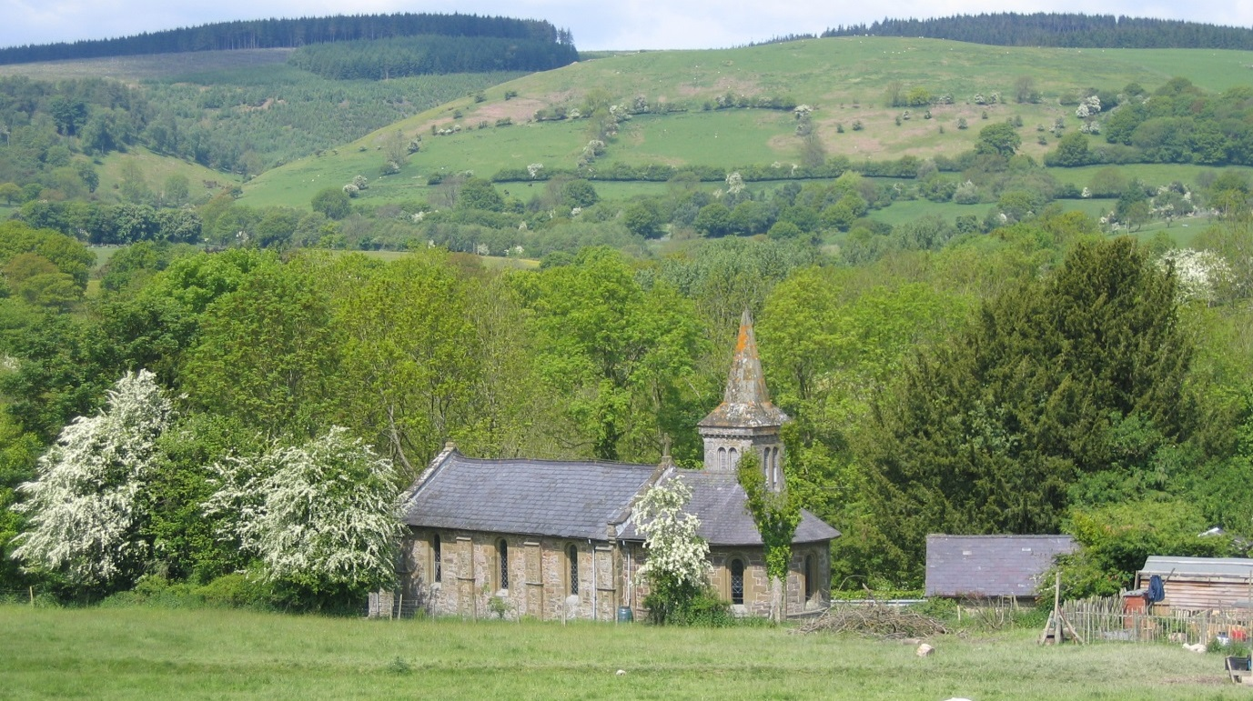
Image: C.Uff
Introduction
St Michael’s and All Angels Church is situated in a rural location on the roadside at Cwm Head (between Marshbrook and Horderley). It has a carriage shed and stable, but no graves. There is a retaining wall along the roadside, but it is otherwise surrounded by oak paling on the east and west and stock fencing against pasture to the south. A previous survey of the churchyard was carried out by J.Thompson in 2005
Survey details
On 21/6/2014 members of SACWG assessed the site. The site was revisited on 6th September.
Ground Flora: Species were recorded from a general walkover. Ferns were also identified.
Trees: The existing map from 2005 was checked and updated if necessary.
Mammals: A baited hedgehog tunnel was left for several nights to collect mammal footprints. Tracks and signs of other mammals were also recorded. Bats were not assessed.
Birds: Any birds seen or heard within churchyard were recorded. Those seen in flight were only recorded if it seemed likely they were using the site. Signs of nesting were noted.
Invertebrates: Any species encountered within the churchyard were identified as far as possible.

Results and management comments
In all 92 species were recorded and summarised below. They included a really good number of grassland indicator species which are becoming increasingly uncommon nationally as traditional hay meadows are lost. Although small, the site appears good enough to achieve County Wildlife Site status.
 | # Species noted | Comments
Ground Flora | 59 (+1 lichen) | The flora was exceptionally rich for such a small site. There was a breath-taking display of common spotted orchids (an estimated 700 flowering spikes), and a closer look revealed a fabulous range of species typical of old flower rich meadows which are becoming so rare these day. Twaybades (22 spikes), cowslip, bird’s-foot trefoil, common knapweed, mouse-ear hawkweed, heath speedwell, ladies’ mantle, rough hawkbit, oxeye daisy, quaking grass, pignut and devil’s- bit scabious are just some of the species worthy of note. The latter species, along with bulbous buttercup were predicted by Thomson to be present, but not seen in 2005.
Trees | 6 | A refreshing lack of exotic tree and shrub species is in keeping with the simple rural character of this church.
Birds | 5 | Although only a few of birds were recorded on the visit to this tiny churchyard, those that were, were worthy of note, particularly nesting swifts. Swifts are suffering huge declines nationally, so to have them nesting here is a real privilege. Swallows were nesting in the carriage shed, and robins also appeared to be nesting.
Insects | 19 | Although no particularly notable species were recorded, the presence of herald moth wings scattered in the porch throughout the autumn were a sign of bat activity.
Mammals | 3 | Mouse/vole and shrew footprints. Also signs of bats (see above)
Reptiles | 0
Grassland Category |  | Species rich neutral grassland of fine quality. Although the flora was not surveyed as thoroughly as the previous survey by J.Thompson, the site appears to be maintaining its diversity, with both orchid species showing a significant increase.
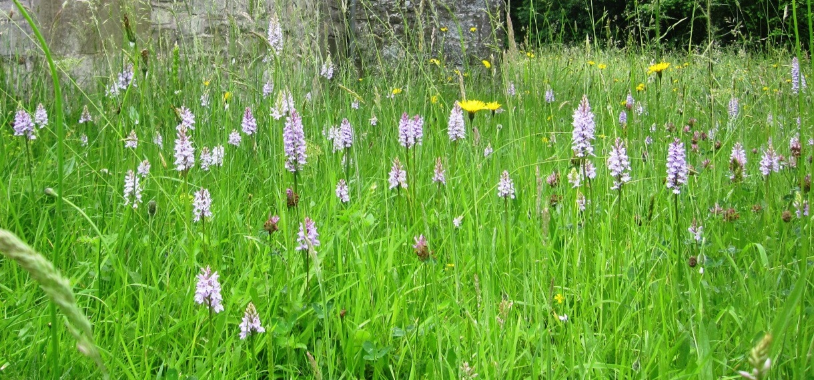

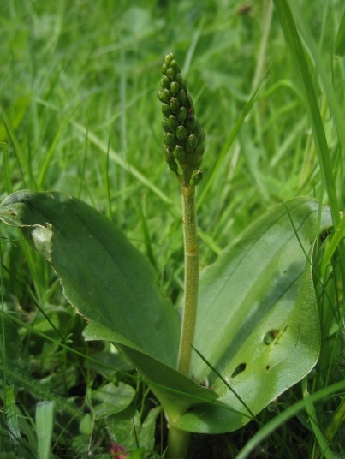
The grassland is managed as a hay meadow, with just the path sides kept short in the summer. This allows the very rich grassland flora to flower and set seed and is clearly benefiting the site. The cut grass is raked off which is good practice. If it is felt that the grassland is starting to get coarser (as sometimes happens with repeated late cuts), an earlier cut every few years will not harm the plants which are perennials. Traditional hay meadows would have been cut varying times from July onwards, depending upon the weather.
Image: C.Uff
Details of managing longer grassland in churchyards can be found on the Caring for God ’s Acre website. http://www.caringforgodsacre.org.uk/
Twaybalde in bud: Image C.Uff

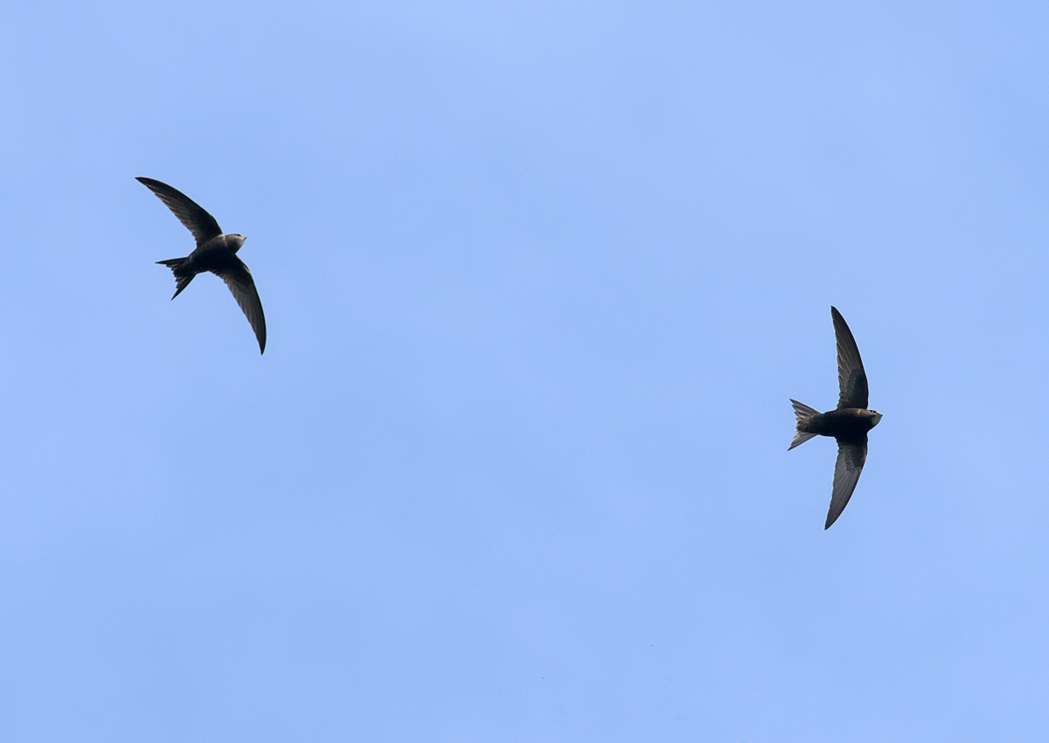
Image: http://northeastwildlife.co.uk/

In addition to the flora, it was great to find swifts nesting. Swifts are a species of conservation concern as their numbers have declined rapidly in recent years. Loss of nest sites due to modern building techniques is thought to be a contributing factor, and churches such as Cwm Head are often valuable nesting sites. It is important to look after these sites and ask for advice if any building works are planned for the roof - the Shropshire swift group can be contacted at http://www.shropshireswifts.org.uk/

Image: http://northeastwildlife.co.uk/

Plants recorded 2014 (English names used where possible)
Group | Plant name
Ferns | Male fern
Flowers | Bird's-foot-trefoil
Flowers | Bluebell
Flowers | Bramble
Flowers | Bugle
Flowers | Buttercup, bulbous
Flowers | Buttercup, creeping
Flowers | Buttercup, meadow
Flowers | Cat's-ear
Flowers | Celandine, lesser
Flowers | Cleavers
Flowers | Clover, red
Flowers | Clover, white
Flowers | Cowslip
Flowers | Daisy
Flowers | Dandelions
Flowers | Dog/field Rose
Flowers | Dog-violet, common
Flowers | Hawkbit, rough
Flowers | Hawkweed, mouse-ear
Flowers | Herb-Robert
Flowers | Hogweed
Flowers | Ivy
Flowers | Knapweed, common
Flowers | Lady's mantle
Flowers | Lady's smock
Flowers | London's pride
Flowers | Meadow-sweet
Flowers | Mouse-ear, common
Flowers | Oxeye daisy
Flowers | Pignut
Flowers | Plantain, ribwort
Flowers | Scabious, devil's-bit
Flowers | Selfheal
Flowers | Sorrel, common
Flowers | Speedwell, germander
Flowers | Speedwell, heath
Flowers | Stinging nettle
Flowers | Stitchwort, greater
Flowers | Strawberry, barren
Group | Plant name
Flowers | Strawberry, wild
Flowers | Thistle, marsh
Flowers | Vetch, bush
Flowers | Vetchling, meadow
Flowers | Willowherb, broad-leaved
Flowers | Willowherb, rosebay
Flowers | Yellow archangel
Flowers | Twayblade, common (22)
Flowers | Spotted-orchid, common (700)
Grasses | Cock's foot grass
Grasses | Crested Dog's Tail
Grasses | Foxtail, meadow
Grasses | Oat-grass, false
Grasses | Quaking-grass
Grasses | Rye grass, perennial
Grasses | Sheep's fescue
Grasses | Sweet Vernal Grass
Grasses | Yorkshire-fog
Lichens | Lepraria vouauxii?
Trees and Shrubs | Ash
Trees and Shrubs | Hawthorn
Trees and Shrubs | Hazel
Trees and Shrubs | Rose - field
Trees and Shrubs | Sycamore
Trees and Shrubs | Yew

Animals recorded 2014 (English names used where possible)
Group | Animal Name
Bird | Chiff chaff
Bird | House Sparrow
Bird | Swallow (nesting)
Bird | Swift (nesting)
Bird | Robin (nesting?)
Coleoptera (Beetles) | ground beetle, Nebria brevicollis
Coleoptera (Beetles) | longhorn beetle, Grammoptera ruficornis
Diptera (Flies) | hoverfly, Syritta pipiens
Diptera (Flies) | hoverfly, Eristalis pertinax
Hymenoptera (Ants, bees and wasps) | mason bee, Osmia laeiania
Hymenoptera (Ants, bees and wasps) | solitary wasp, Crossocerus elongatulus
Hymenoptera (Ants, bees and wasps) | solitary wasp, Crossocerus dimidiatus
Hymenoptera (Ants, bees and wasps) | ruby-tailed wasp, Chrysis sp
Hymenoptera (Ants, bees and wasps) | mining bee, Lasioglossum calceatum
Hymenoptera (Ants, bees and wasps) | bumblebee, buff-tailed
Hymenoptera (Ants, bees and wasps) | solitary wasp, Pemphredon lugubris
Hymenoptera (Ants, bees and wasps) | leaf cutter bee, Megochile willughbiella
Hymenoptera (Ants, bees and wasps) | bumblebee, white-tailed
Lepidoptera (Butterflies and moths) | moth, herald
Lepidoptera (Butterflies and moths) | butterfly, small tortoiseshell
Lepidoptera (Butterflies and moths) | butterfly, speckled wood
Mammal | bat (droppings)
Mammal | mouse/vole (footprints)
Mammal | shrew (footprints)
Snail | snail, common garden
Snail | snail, glass (probably more than one sp)
Snail | snail, white lipped garden

