The Old Cemetery, Church Stretton SO452935
A Wildlife Survey by Strettons Area Community Wildlife Group (SACWG)
Report by Caroline Uff
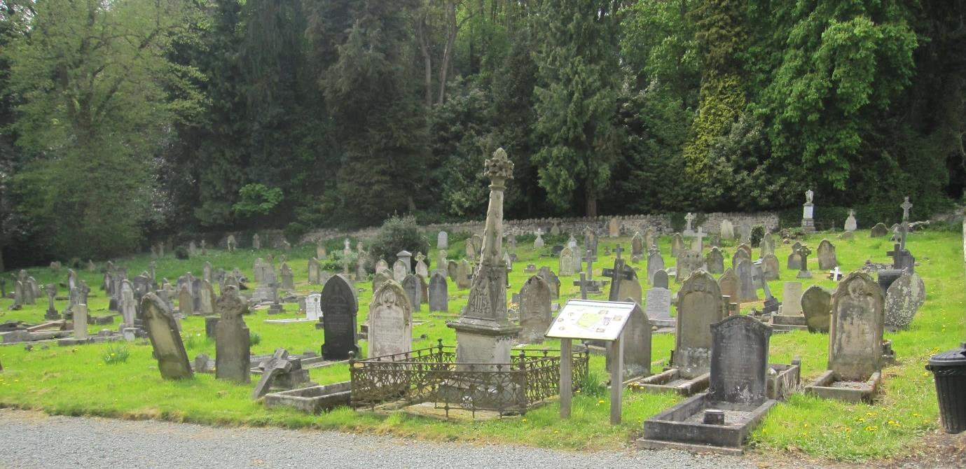
Image: C.Uff
Introduction
The Old Cemetery, Church Stretton, is situated on the edge of town on the corner of Cunnery Road and High Street. The churchyard is bound by stone walls. It is mostly open, but shaded in the southwest adjacent to the wooded hillside. Much of the site is regularly mown to medium height. The shaded area and part of the grassland was un-mown at the time of survey allowing spring flowers to bloom. There have been a couple of previous reports.
- Report on the trees at Church Stretton Old Cemetery 2000. Shropshire Hills Countryside Unit / Caring for God’s Acre.
- Church Stretton Cemetery. John Thompson 1999.

Survey details
On 30/4/2014, members of SACWG were joined by staff from Caring for God’s Acre (CfGA) to assess the site.
Ground Flora: Species were recorded from a general walkover. Diversity was assessed in one or two quadrats (2x2m). This was used to trial a ‘churchyard companion’ being developed by CfGA which aimed to classify the type of grassland present. Ferns on the walls were also identified.
Trees: The existing tree survey and map from 2000 was updated.
Mammals: a baited hedgehog tunnel was left for two nights to collect mammal footprints. Tracks and signs of other mammals were also recorded. Bats were not assessed.
Birds: Any birds seen or heard within churchyard were recorded. Those seen in flight were only recorded if it seemed likely they were using the site. Signs of nesting were noted.
Invertebrates: Any species encountered within the churchyard were identified as far as possible. Sweep nets and beating trays were used.
Reptile mats: Two mats (felt roofing tiles) were left in situ for approx 1 month around the period of the visit to act as refuges for reptiles.
Results and comments
In all, 108 species were recorded and summarised below – the full list is given at the end. The existing tree survey and churchyard map was updated below. Parts of the grassland were quite diverse and should remain so, providing grass clippings are removed. Leaving some areas of longer grass to flower can be very important for wildlife as well as providing a colourful display. Details of managing longer grassland in churchyards can be found on the Caring for God’s Acre website. http://www.caringforgodsacre.org.uk/
 | # Species recorded | Comments
Ground Flora | 55 | The shaded area (uncut) had a woodland flora and was a carpet of bluebells, lesser celandines and ramsons. The grassy areas included ladies bedstraw and oxeye daisy which are indicators of species rich grasslands which are becoming increasingly uncommon in our countryside.
Trees | 13 | The trees were mainly native broad leaved species. The largest trees present were and oak, lime and Wych Elm.
Birds | 11 | A range of widespread species including one of the first chiff chaffs of the year.
Invertebrates | 28 | A very nice range of invertebrates. Two finds were of particular significance. Scarlet tiger moth caterpillars were feeding on the green alkanet. This south western species was recorded as an adult for the first time in Shropshire here in Stretton in 2013, and this find confirms breeding. Another uncommon species, the bordered shieldbug, was found in good numbers under the reptile mat adjacent to the woodland wall. It is a burrowing species associated with cleavers.
Mammals | 1 | Mouse footprints were recorded from the tunnel.
Reptiles | 0
Grassland category |  | Semi- improved neutral grassland of moderate diversity (as determined by CfGA’s churchyard companion)
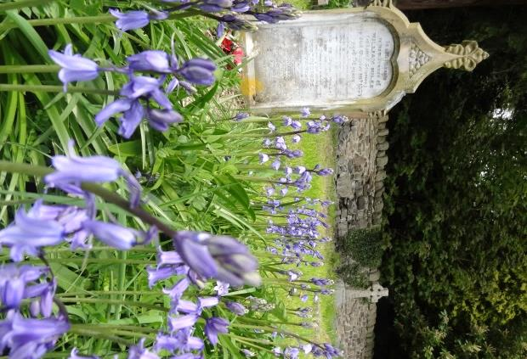
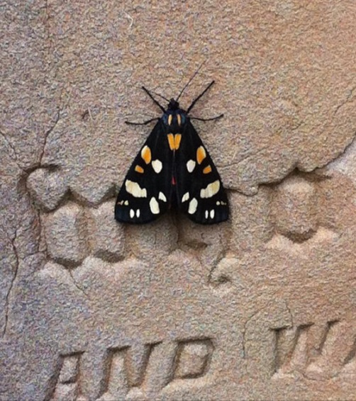
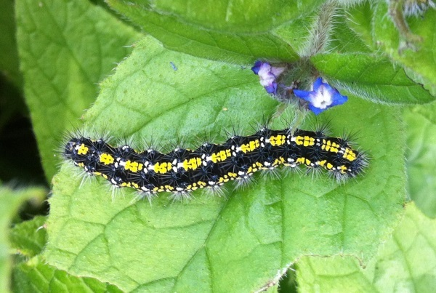
Image: C.Uff
Image: G.Wenman
Image: G.Wenman
Bluebells and Scarlet Tiger moth were worthy of note
Tree No. | Common Name | Age | Height(m) | Circumference cm | Canopy  Width m | Notes
1 | Lime – no longer present
2 | Sycamore – no longer present
3 | Sycamore/ Thuja/ Ash/ Horse Chestnut/Laurel | Mature | 25 |  |  | Mixed mature deciduous woodland with Thuja infringing.-. Much growth encroaching over the cemetery boundary
5 | Box Holly | Mature | 38 |  |  | Overgrown form Growing in the centre of dense growth
6 | Sycamore | Young/ Mature | 12 |  |  | Growing in the centre- of dense growth
7 | Sycamore | Young/ Mature | 13 |  |  | Bifurcates at 0.5m. 2x dominant leaders, 1x sub-dominant
8 | Lime | Mature | 38 | 380 | 8 | Dense epicormic growth at base, bifurcates at 6m.
9 | Oak | Mature | 35 | 386 | 12 | High canopy developing at 12m. Form suppressed by T8
10 | Yew | Young/ Mature | 10 | 97 | 9
11 | Thuja – no longer present
12 | Sycamore – no longer present
13 | Sycamore – no longer present
14 | Portuguese Laurel | Young/ Mature | 7
15 | Oak – dead
16 | Variegated Holly | Young/ Mature | 7 | 77 | 3.5
17 | Variegated Holly | Young/ Mature | 7
18 | Holly | Mature | 20 | 190 | 7 | Forming a screen from private residence
19 | Holly | Mature | 12 |  |  | Forming a screen from private residence
20 | Yew | Young | 6 | 110 | 4
21 | Oak | Mature | 30 | 200 | 13 | Ivy covered throughout canopy, pollarded in past
22 | Sycamore – no longer present
23 | Yew | Young/ Mature | 8
24 | Wych Elm | Young/ Mature | 7 | 27 |  | Many stemmed
25 | Holly | Young/ Mature | 7
26 | Holly | Young/ Mature | 7
27 | Sycamore | Young/ Mature | 15 | 70 | 6 | Ivy covered throughout crown
28 | Sycamore | Young/ Mature | 14 |  |  | Excessive fruiting, early leaf drop.

Tree No. | Common Name | Age | Height(m) | Circumference cm | Canopy | Notes
29 | Sycamore | Young/ Mature | 14
30 | Sycamore | Young/ Mature | 16
31 | Sycamore | Young/ Mature | 16
32 | Sycamore | Mature | 16 |  |  | 2x stems. One dominant stem growing towards cemetery
33 | Norway Maple | Mature | 30 |  |  | 6 stems
34 | Norway Maple | Mature | 28 |  |  | Very fine
35 | Sycamore – no longer present
36 | Sycamore- dead
37 | Norway Maple– dead
38 | Goat Willow– dead
39 | Hawthorn | Young/ Mature | 8
40 | Ash - dead
41 | Sycamore | Mature | 20 |  |  | 3 stemmed, Standing at the roadside corner
42 | Holly | Mature | 11
44 | Laurel | Young | 3 | 2
45 | Ash | Young | n/a |  |  | Suckers growing from old stump
46 | Laurel | Young | 2 | 10 | 4
47 | Yew | Young | 4.5 | 105 | 3
48 | Yew | Young | 5.6 | 125 | 4
49 | Hawthorn | Young | 2 | 23 | 2
50 | Holly/Laurel | Young | 2 |  | 4
51 | Sycamore | Young | 12 | 70 | 5
52 | Sycamore | Young | 12 | 70 | 5
53 | Norway Maple | Young | 15
54 | Norway Maple | Young | 15
55 | Holly | Young | 5

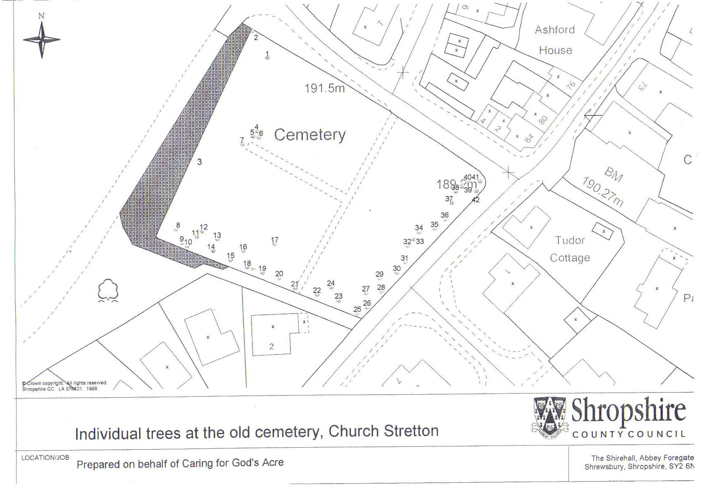
44*
*51
*52
*53
*54
*55
*49
*50
*48
*21
19*
47*
46*
20*
*45
Detail of tree positions around memorial area at southern end of path

Plants recorded 2014 (English names used where possible)
Group | Plant name
Ferns | Wall Rue
Flowers | Alkanet, green
Flowers | Bedstraw, lady's
Flowers | Bluebell
Flowers | Bramble
Flowers | Buttercup, creeping
Flowers | Buttercup, meadow
Flowers | Cat's-ear
Flowers | Celandine, lesser
Flowers | Cleavers
Flowers | Clover, red
Flowers | Clover, white
Flowers | Cow parsley
Flowers | Dandelions
Flowers | Dog/field Rose
Flowers | Dog-violet, common
Flowers | Field/wood forget-me-not
Flowers | Ground elder
Flowers | Ground ivy
Flowers | Groundsel
Flowers | Bittercress, hairy
Flowers | Herb-Robert
Flowers | Hogweed
Flowers | Ivy
Flowers | Lady's mantle
Flowers | Lady's smock
Flowers | Trefoil, lesser
Flowers | Lettuce, wall
Flowers | Lord's-and-ladies
Flowers | Mouse-ear, common
Flowers | Oxeye daisy
Flowers | Parsley piert
Flowers | Plantain, ribwort
Flowers | Poppy, Welsh
Flowers | Primrose
Flowers | Ramsons
Flowers | Stonecrop, reflexed
Flowers | Speedwell, slender
Flowers | Sorrel, common
Flowers | Sow Thistle, smooth
Flowers | Speedwell, germander
Flowers | Stinging nettle
Flowers | Strawberry, barren
Group | Plant name
Flowers | Vetch, bush
Flowers | Wild strawberry
Flowers | Willowherb, broad-leaved
Flowers | Willowherb, rosebay
Flowers | winter cress
Flowers | Wood anemone
Flowers | Wood avens
Flowers | Wood-rush, field
Flowers | Yellow pimpernel
Grasses | Foxtail, meadow
Grasses | Sweet Vernal Grass
Mosses | Rhytidiadelphus squarrosus
Trees and Shrubs | Ash
Trees and Shrubs | Box holly
Trees and Shrubs | Hawthorn
Trees and Shrubs | Holly
Trees and Shrubs | Horse Chestnut
Trees and Shrubs | Laurel, Cherry
Trees and Shrubs | Lime
Trees and Shrubs | Maple Norway
Trees and Shrubs | Oak
Trees and Shrubs | Sycamore
Trees and Shrubs | Thuja
Trees and Shrubs | Wych elm
Trees and Shrubs | Yew

Animals recorded 2014 (English names used where possible)
Bird | Black cap
Bird | Blackbird
Bird | Blue tit
Bird | Carrion crow
Bird | Chaffinch
Bird | Chiff chaff
Bird | Dunnock
Bird | Great tit
Bird | Robin
Bird | Wood pigeon
Bird | Wren
Coleoptera (Beetles) | ladybird, 14-spot
Coleoptera (Beetles) | leaf beetle, Phaedon armouraciae
Coleoptera (Beetles) | leaf beetle, Altica lyrthri
Coleoptera (Beetles) | ladybird, orange
Diptera (Flies) | hoverfly, Rhingia campestris
Diptera (Flies) | hoverfly, Myathropa florea
Diptera (Flies) | hoverfly, Eristalis pertinax
Hemiptera (bugs) | Shieldbug, bordered
Hemiptera (bugs) | Shieldbug, forget-me-not
Hemiptera (bugs) | Shieldbug, green
Hymenoptera (Ants, bees and wasps) | mining bee, Nomada flava
Hymenoptera (Ants, bees and wasps) | ant, Formica fusca
Hymenoptera (Ants, bees and wasps) | ant, Myrmica rubra
Hymenoptera (Ants, bees and wasps) | bumblebee, common carder
Hymenoptera (Ants, bees and wasps) | Common wasp
Hymenoptera (Ants, bees and wasps) | Bumblebee, Bombus sylvestris
Hymenoptera (Ants, bees and wasps) | bumblebee, early
Hymenoptera (Ants, bees and wasps) | Honey Bee
Hymenoptera (Ants, bees and wasps) | mason Bee, Osmia bicornis
Hymenoptera (Ants, bees and wasps) | solitary bee, Andrena carantonica
Hymenoptera (Ants, bees and wasps) | solitary bee, Nomada marshamella
Hymenoptera (Ants, bees and wasps) | mining bee, Andrena fulva
Hymenoptera (Ants, bees and wasps) | bumblebee, tree
Hymenoptera (Ants, bees and wasps) | mining bee, Lasioglossum calceatum (nesting aggregation)
Lepidoptera (Butterflies and moths) | butterfly, green veined white
Lepidoptera (Butterflies and moths) | butterfly, Holly blue
Lepidoptera (Butterflies and moths) | butterfly, orange tip
Lepidoptera (Butterflies and moths) | moth, scarlet tiger
Mammal | mouse/vole

