Greenhills Cemetery, Church Stretton SO448928
A Wildlife Survey by Strettons Area Community Wildlife Group (SACWG)
Report by Caroline Uff
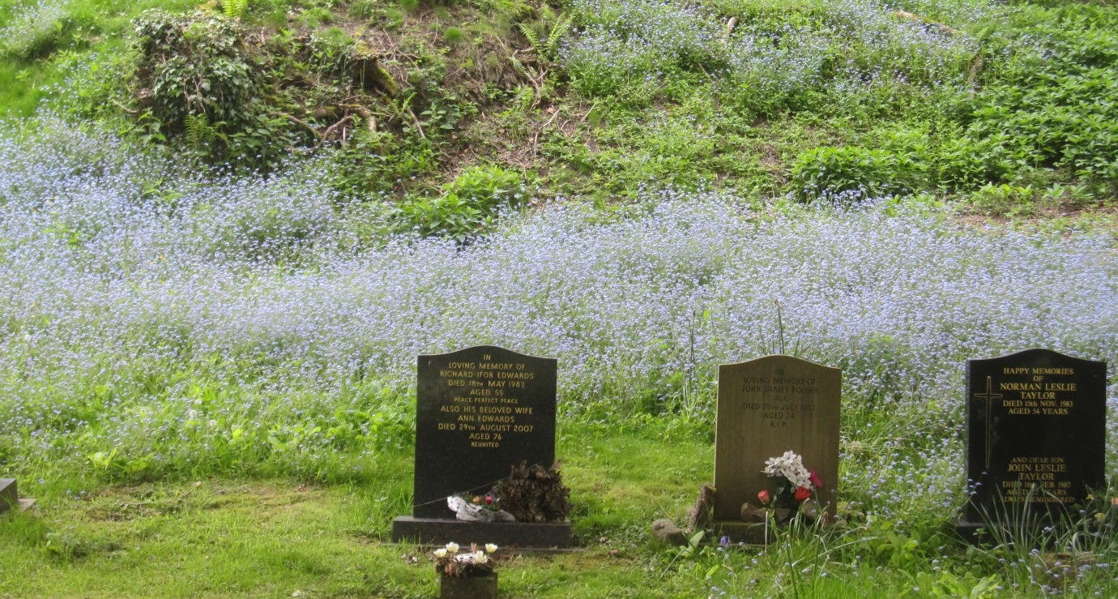
Image: C.Uff
Introduction
Greenhills Cemetery, Church Stretton, is situated on the edge of town on a quite lane adjacent to the Church Stretton Allotments, but otherwise surrounded by woodland and pasture and bounded by hedges and trees.

Survey details
The site was assessed by members of SACWG on 17/5/2014.
Ground Flora: Species were recorded from a general walkover. Diversity was assessed in one or two quadrats (2x2m). This was used to trial a ‘churchyard companion’ being developed by CfGA which aimed to classify the type of grassland present.
Trees: As SACWG were unaware of existing surveys, the trees of the churchyard were both listed and mapped
Mammals: a baited hedgehog tunnel was left for two nights to collect mammal footprints. Tracks and signs of other mammals were also recorded.
Birds: Any birds seen or heard within cemetery were recorded. Those seen in flight were only recorded if it seemed likely they were using the site. Signs of nesting were noted.
Invertebrates: Most species encountered/ netted within the cemetery were identified.
Reptile mats: Two mats (felt roofing tiles) were left in situ for approx. 1 month around the period of the visit to act as refuges for reptiles.
Results and comments
In all, 114 species were recorded and summarised below – the full list is given at the end. Much of the cemetery was kept mown quite short, but the banks, particularly those adjacent to the woodland had been left unmown at the time of survey to allow spectacular show of flowering forget-me-not.
 | # Species recorded | Comments
Ground Flora | 56 | Along the woodland edge, woodland species such as bluebell, ramson and enchanter’s nightshade were nice to see. Within the open grassy areas, some species indicative of traditional old grasslands were present including the delicate mouse-ear hawkweed.
Trees | 14 | The hedgerows surrounding the cemetery contained mostly native tree species, with some ornamental planting in the centre.
Birds | 18 | This site was particularly rich in birdlife, with nesting nuthatch and nesting greater spotted woodpecker in the boundary trees.
Invertebrates | 25 | The banks of forget-me-not supported the uncommon forget-me-not shieldbug. Unusually, this burial ground included some wetland species (stoneflies and damselflies) which are likely to have come from the nearby wetland area.
Mammals | 1 | Mouse/vole footprints were plentiful in the tunnel placed along the woodland edge, but it was not possible to say which species.
Reptiles | 0
Grassland category |  | The ground flora was categorised as semi- improved neutral grassland of moderate diversity, using the churchyard companion (CfGA).

The grouped plantings of shrubs and thick hedgerows found here will benefit wild birds. It is important to leave standing deadwood in the hedgerows as it is of great value to wildlife, including many of the species recorded here.
Leaving areas of longer grass can also be very important for wildlife, as well as providing a colourful display as seen with the forget-me-nots on the bank here. In order to maintain species richness is it important that grass cuttings are raked off. Details of managing longer grassland can also be downloaded in the ‘managing churchyards &burial grounds’ action pack available from the Caring for God’s Acre website http://www.caringforgodsacre.org.uk/
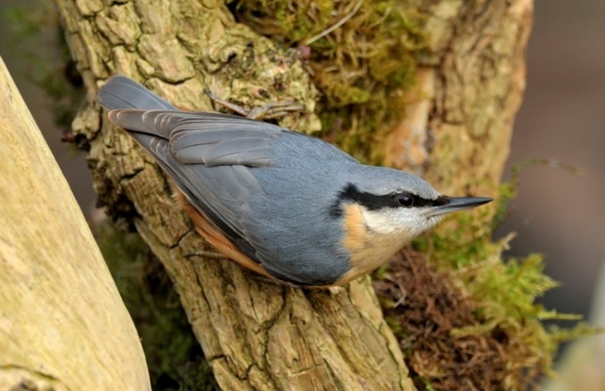
Nuthatch (left) and great spotted woodpecker both nest in holes in trees around the cemetery.
Images: http://northeastwildlife.co.uk/

Tree No. | Common Name
1 | Copper Beech
2 | Silver Birch
3 | Hawthorn
4 | Holly
5 | Ash
6 | Elder
7 | Lime
8 | Cherry
9 | Sycamore
10 | Oak sp
11 | Beech
12 | Blackthorn
13 | Hazel
14 | Viburnum
Sketch map of Greenhills Cemetery (not to scale) showing positions of trees
Detail of tree positions around memorial area at southern end of path
19*
20*
*45
46*
47*
*49
*50

Entrance

Plants recorded 2014 (English names used where possible)
Group | Plant name
Ferns | Bracken
Ferns | Buckler-fern, broad
Flowers | Bluebell
Flowers | Burdock
Flowers | Buttercup, bulbous
Flowers | Buttercup, creeping
Flowers | Campion, red
Flowers | Cat's-ear
Flowers | Celandine, greater
Flowers | Celandine, lesser
Flowers | Cleavers
Flowers | Clover, white
Flowers | Creeping Thistle
Flowers | Daisy
Flowers | Dandelions
Flowers | Dock, broad-leaved
Flowers | Dog/field Rose
Flowers | Dog's mercury
Flowers | Dog-violet, common
Flowers | Enchanter's-nightshade
Flowers | Field/wood forget-me-not
Flowers | Fox and cubs
Flowers | Foxglove
Flowers | Garlic mustard
Flowers | Ground ivy
Flowers | Hawkweed, mouse-ear
Flowers | Herb-Robert
Flowers | Hogweed
Flowers | Ivy
Flowers | Lord's-and-ladies
Flowers | Mouse-ear, common
Flowers | Nipplewort
Flowers | Pimpernel, scarlet
Flowers | Plantain, ribwort
Flowers | Primrose
Flowers | Ragwort
Flowers | Ramsons
Flowers | Sorrel, common
Flowers | Speedwell, germander
Flowers | Speedwell, thyme-leaved
Flowers | Speedwell, wall
Flowers | Stinging nettle
Flowers | Strawberry, barren
Group | Plant name
Flowers | Thistle, marsh
Flowers | Thistle, spear
Flowers | Vetch, bush
Flowers | Wavy bittercress
Flowers | Welted Thistle
Flowers | Willowherb, broad-leaved
Flowers | Wood avens
Flowers | Wood-rush, field
Flowers | Yarrow
Flowers | Yellow archangel
Grasses | Cock's foot grass
Grasses | Sweet Vernal Grass
Grasses | Timothy
Grasses | Yorkshire-fog
Trees and Shrubs | Ash
Trees and Shrubs | Beech
Trees and Shrubs | Blackthorn
Trees and Shrubs | Cherry
Trees and Shrubs | Copper Beech
Trees and Shrubs | Elder
Trees and Shrubs | Hawthorn
Trees and Shrubs | Hazel
Trees and Shrubs | Holly
Trees and Shrubs | Lime
Trees and Shrubs | Oak
Trees and Shrubs | Silver Birch
Trees and Shrubs | Sycamore
Trees and Shrubs | Viburnum

Animals recorded 2014 (English names used where possible)
Groups | Animal name
Bird | Greater Spotted Woodpecker (nest)
Bird | Nuthatch (nest)
Bird | Black cap
Bird | Blackbird
Bird | Blue tit
Bird | Bullfinch
Bird | Carrion crow
Bird | Chaffinch
Bird | Chiff chaff
Bird | Dunnock
Bird | Goldcrest
Bird | Great tit
Bird | Greenfinch
Bird | Jackdaw
Bird | Redstart
Bird | Robin
Bird | Wood pigeon
Bird | Wren
Mammal | mouse/vole (footprints)
Coleoptera (Beetles) | ladybird, 14-spot
Coleoptera (Beetles) | ladybird, 7-spot
Coleoptera (Beetles) | cardinal beetle, Pyrochroa serraticornis
Coleoptera (Beetles) | beetle, Byturus tomentosus
Diptera (Flies) | cranefly, Tipula oleracea
Diptera (Flies) | hoverfly, Merodon equestris
Diptera (Flies) | hoverfly, Syritta pipiens
Hemiptera (bugs) | Sheildbug, forget-me-not
Hymenoptera (Ants, bees and wasps) | mining bee, Andrena haemorrhoa
Hymenoptera (Ants, bees and wasps) | mining bee, Andrena nigroaenea
Hymenoptera (Ants, bees and wasps) | mining bee, Lasioglossum calceatum
Hymenoptera (Ants, bees and wasps) | mining bee, Nomada fabriciana
Hymenoptera (Ants, bees and wasps) | mining bee, Nomada flava
Hymenoptera (Ants, bees and wasps) | mining bee, Nomada ruficornis
Hymenoptera (Ants, bees and wasps) | bumblebee, Common carder
Hymenoptera (Ants, bees and wasps) | bumblebee, Bombus vestalis
Hymenoptera (Ants, bees and wasps) | Honey Bee
Hymenoptera (Ants, bees and wasps) | bumblebee, Red-tailed
Hymenoptera (Ants, bees and wasps) | bumblebee, White-tailed
Lepidoptera (Butterflies and moths) | butterfly, green veined white
Lepidoptera (Butterflies and moths) | butterfly, large white
Lepidoptera (Butterflies and moths) | butterfly, orange tip
Lepidoptera (Butterflies and moths) | butterfly, small white
Odonata (dragonflies and damselflies) | Large red damselfly
Plecoptera | a stonefly

