St. Laurence’s Church, Church Stretton SO452936
A Wildlife Survey by Strettons Area Community Wildlife Group (SACWG)
Report by Caroline Uff
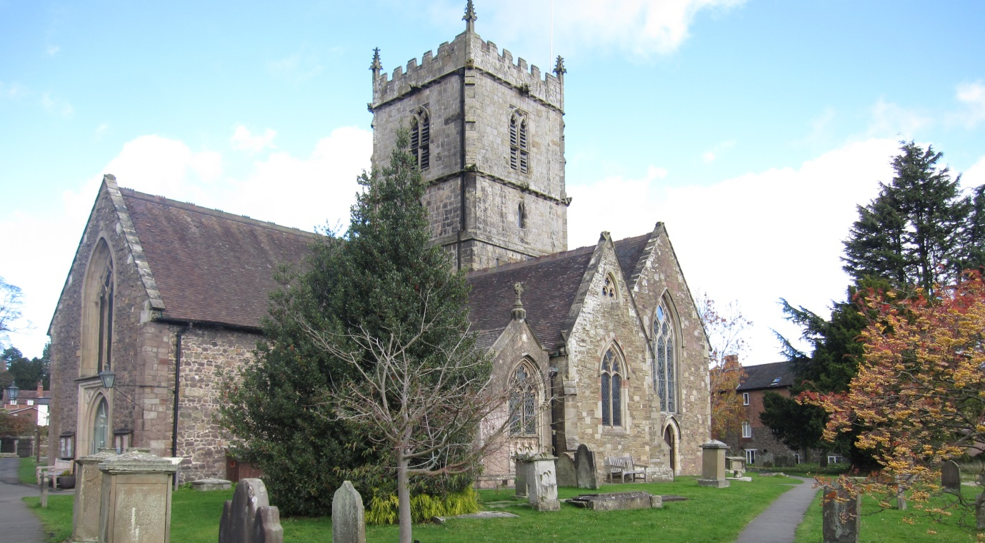
Image: C.Uff
Introduction
St. Laurence’s Church is situated in the centre of Church Stretton town. The churchyard is bounded by stone walls and has both open and shady areas. It is regularly mown except for a patch in the north-west which is left to flower. There have been several previous list/reports of the churchyard plants as follows:
- St Laurence’s churchyard flora. Helen Davidson 2004 (this also includes reference to a species list compiled by Sarah Whild in 1997).
- Report on Trees in the Churchyard of St. Laurence’s Church. Caring for God’s Acre / Peter Norman 1999.
- St. Laurence’s Churchyard Lichens recorded June 2006. Sue Swales.

Survey details
On 30/4/2014, member of SACWG were joined by staff from Caring for God’s Acre (CfGA) to assess the site.
Ground Flora: Species were recorded from a general walkover. Diversity was assessed in one or two quadrats (2x2m). Data was used to trial a ‘churchyard companion’ being developed by CfGA which aimed to classify the type of grassland present. Ferns on the walls were also identified, but lower plants were not.
Trees: The existing tree survey and map from 1999 was updated.
Mammals: A baited hedgehog tunnel was left for two nights to collect mammal footprints. Tracks and signs of other mammals were also recorded. Bats were not assessed.
Birds: Any birds seen or heard within churchyard were recorded. Those seen in flight were only recorded if it seemed likely they were using the site. Signs of nesting were noted.
Invertebrates: Any species encountered within the churchyard were identified as far as possible. Seep nets and beating trays were used.
Reptile mats: Two mats (felt roofing tiles) were left in situ for approx. 1 month around the period of the visit to act as refuges for reptiles.
Results and comments
Ninety nine species were recorded – the full list is given at the end of the document. It was great to see a section left uncut to flower and set seed, as well as bird boxes on the site.
 | # Species recorded | Comments
Ground Flora | 60 | Worthy of note were ladies bedstraw, salad burnet, heath speedwell, mouse-ear hawkweed and black knapweed. These wildflowers are indicators of traditional species rich lowland grasslands which are becoming uncommon nationally. Harebell had been recorded in the past, but was not seen in 2014. However it is a late summer species so may still be present.
Trees | 10 | A mixture of ornamental and native species. Yew present with girth of 440cm
Birds | 5 | Bird boxes present but not checked. Too early to check for swifts.
Insects | 22 | Yellow meadow ant is a species associated with old grasslands
Mammals | 2 | Hedgehog droppings were worthy of note as hedgehogs numbers have plummeted in recent years.
Reptiles | 0
Grassland Type |  | The ground flora was categorised as semi- improved neutral lowland grassland of moderate diversity, using the churchyard companion (CfGA).
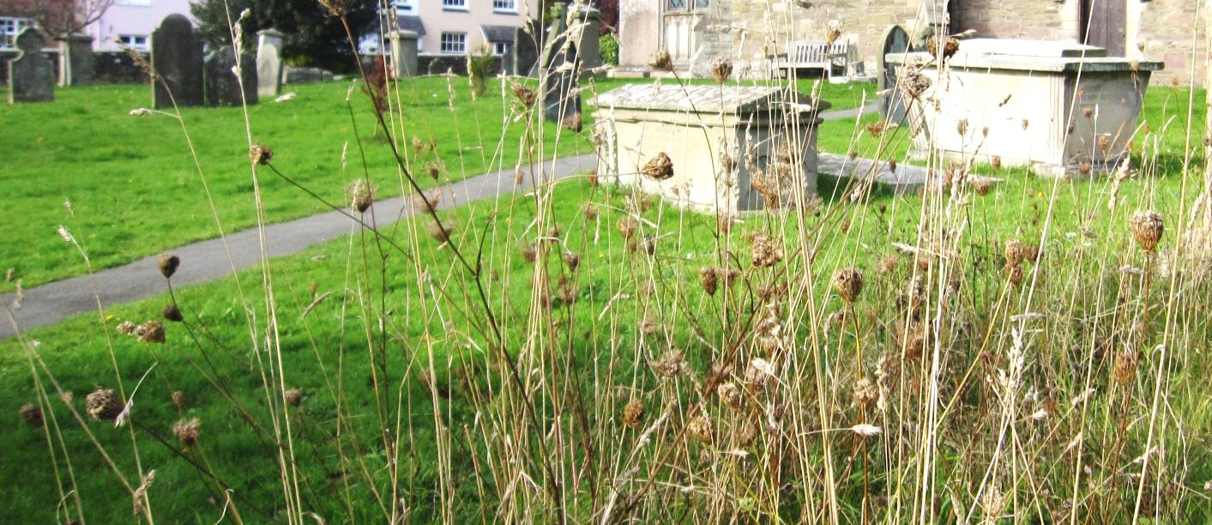

A
As well as providing a wonderful splash of colour during the summer , the seed heads go on to provide food and shelter for wildlife in the autumn. Image C.Uff
A sunny area of the churchyard was left uncut and this had very good grassland diversity and included some of the more significant indicator species. This patch was still uncut in November, providing seed heads for birds and overwintering insects. If left uncut in the long term, the patch may start to deteriorate, and will benefit from a late summer cut some years. Details of managing longer grassland are in the ‘managing churchyards &burial grounds’ action pack available for free download on the Caring for God’s Acre website http://www.caringforgodsacre.org.uk/

Tree  no | Common Name | No. in group | Circumference (cm.) | No. of trunks | Height (m) | Spread (m) | Age Class | comments
1 | Douglas Fir | 1 | 336 | 1 | 40 | 16 | Early maturity
2 | English oak | 1 | 198 | 1 | 25 | 17 | Early maturity
3 | Douglas fir – felled Feb 2014 | 1 | (366)
4 | Silver birch | 1 | 178 | 1 | 16 | 16 | Mature
5 | Holly – no longer present
6 | Cypress – no longer present
7 | Deodar | 1 | 288 | 1 | 30 | 15 | Mature | Some branches removed
8 | Yew | 1 | 440 | 7 | 10 | 12 | Mature
9 | Lawsons Cypress-felled Feb 2014
10 | Lawsons Cypress – felled Feb 2014
11 | Douglas Fir – felled Feb 2014
12 | Holly – long dead
13 | Rowan ‘Joseph Rock’ | 1 | 55 | 1 | 4 | 4 | Young
14 | Japanese cherry | 1 | up to 76 | 3 | 10 | 7.5 | Young
15 | Snakebark maple | 1 | 48 | 1 | 2 | 3 | Young | Diseased/ dying
16 | Holly | 1 | Up to 54 | 9 | 6 | 4 | Young
17 | Yew | 1 | 22 | 3 | 3 | 2 | Young
18-21 | Yew |  | 2 | 1 | 0.5-1 | 0.5 | Young
As well as this patch, there were also some diverse areas in the shorter grassland, and providing grass clippings are removed, these species should persist even if mown regularly. The shaded areas were less diverse and several large trees had recently been felled and were awaiting removal. The tree survey and map from 2000 was updated below.

Above: 2014 List of trees updated from Peter Norman’s Survey 1999 of St. Laurence's Churchyard, Church Stretton. The positions of the trees are mapped below.
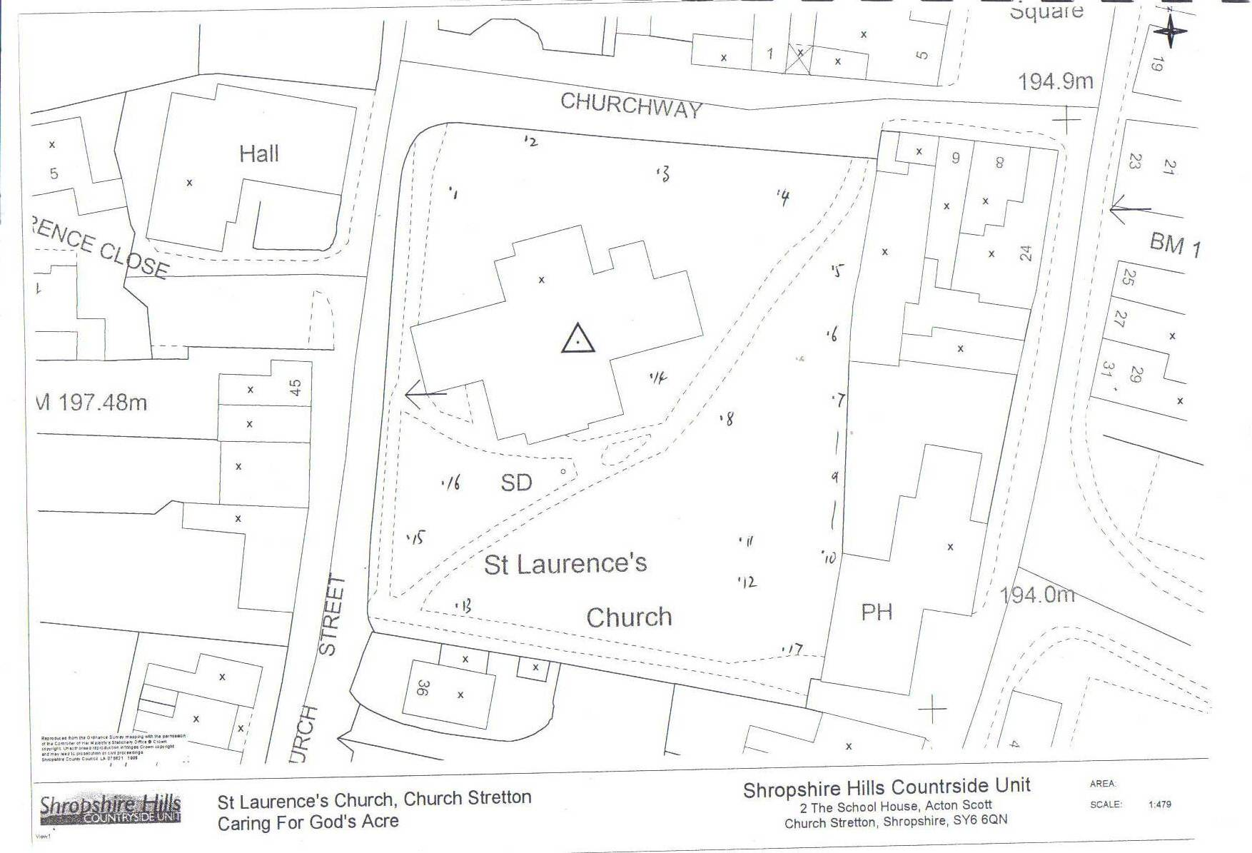
*18
*19
*20
21*

Group | Plant name
Flowers | Alkanet, green
Flowers | Bedstraw, lady's
Flowers | Bittercress, hairy
Flowers | Bramble
Flowers | Buttercup, bulbous
Flowers | Buttercup, creeping
Flowers | Buttercup, meadow
Flowers | Carrot, wild
Flowers | Cat's-ear
Flowers | Celandine, lesser
Flowers | Chickweed, common
Flowers | Cleavers
Flowers | Clover, white
Flowers | Daisy
Flowers | Dandelions
Flowers | Dock, broad-leaved
Flowers | Feverfew
Flowers | Field/wood forget-me-not
Flowers | Garlic mustard
Flowers | Groundsel
Flowers | Hawkweed, mouse-ear
Flowers | Herb-Robert
Flowers | Honesty
Flowers | Ivy
Flowers | Knapweed, common
Flowers | Lady's smock
Flowers | Lamb's Lettuce
Flowers | Lettuce, wall
Flowers | Mallow, common/musk
Flowers | Mouse-ear, common
Flowers | Nipplewort
Flowers | Oxeye daisy
Flowers | Petty Spurge
Flowers | Plantain, ribwort
Flowers | Primrose
Flowers | Salad burnet
Flowers | Sorrel, common
Flowers | Sow Thistle, smooth
Flowers | Speedwell, germander
Flowers | Speedwell, heath
Flowers | Speedwell, thyme-leaved
Flowers | Speedwell, wall
Plant species recorded 2014 (English names used where possible)
Group | Plant name
Flowers | Square-stalked willowherb
Flowers | Strawberry, barren
Flowers | Thistle, spear
Flowers | Vetch, common
Flowers | Wavy bittercress
Flowers | Willowherb, broad-leaved
Flowers | Willowherb, rosebay
Flowers | Wood avens
Flowers | Wood-rush, field
Flowers | Woundwort, hedge
Flowers | Yarrow
Ferns | Hart's tongue
Ferns | Wall Rue
Grasses | Cock's foot grass
Grasses | Sheep's fescue
Grasses | Sweet Vernal Grass
Lichens | several
Mosses | several, incl Rhytidiadelphus squarrosus
Trees and Shrubs | Deodar
Trees and Shrubs | Douglas Fir
Trees and Shrubs | Elder
Trees and Shrubs | Holly
Trees and Shrubs | Oak, English
Trees and Shrubs | Ornamental cherry
Trees and Shrubs | Rowan
Trees and Shrubs | Silver Birch
Trees and Shrubs | Snakebark Maple
Trees and Shrubs | Yew

Animal species recorded 2014 (English names used where possible)

Group | Animal name
Bird | Blackbird
Bird | Blue tit
Bird | Chaffinch
Bird | Chiffchaff
Bird | Robin
Mammal | Hedgehog (droppings)
Mammal | mouse/vole (footprints)
Coleoptera (Beetles) | cardinal beetle, Pyrochroa serraticornis
Coleoptera (Beetles) | ground beetle, Bembidion quadrimaculatum
Coleoptera (Beetles) | ground beetle, Pterostichus maddidus
Coleoptera (Beetles) | ladybird, 7-spot
Coleoptera (Beetles) | ladybird, larch
Coleoptera (Beetles) | ladybird, pine
Diptera (Flies) | fly, St Mark's
Diptera (Flies) | hoverfly, Chrysotoxum sp
Hymenoptera (Ants, bees and wasps) | ant, yellow meadow
Hymenoptera (Ants, bees and wasps) | bumblebee, buff-tailed
Hymenoptera (Ants, bees and wasps) | bumblebee, common carder
Hymenoptera (Ants, bees and wasps) | bumblebee, white-tailed
Hymenoptera (Ants, bees and wasps) | Honey Bee
Hymenoptera (Ants, bees and wasps) | mason bee, Osmia caerulescens
Hymenoptera (Ants, bees and wasps) | mason bee, Osmia bicornis
Hymenoptera (Ants, bees and wasps) | mining bee, Lasioglossum calceatum
Hymenoptera (Ants, bees and wasps) | solitary bee, Andrena bicolor
Lepidoptera (Butterflies and moths) | butterfly, large white
Lepidoptera (Butterflies and moths) | butterfly, orange tip
Lepidoptera (Butterflies and moths) | butterfly, small tortoiseshell
Lepidoptera (Butterflies and moths) | micromoth, 20-plume
Lepidoptera (Butterflies and moths) | moth, spruce carpet

