UPPER CLUN COMMUNITY WILDLIFE GROUP
BIRD GROUP NEWSLETTER AUTUMN 2014

MAGPIE: IT'S NOT BLACK AND WHITE!
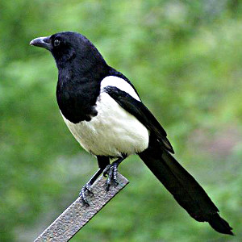
How do you feel about Magpies? They seem always to have attracted decidedly mixed views. The 'mag' bit of Magpie's name comes from mediaeval slang for 'chatterbox' - a hint that people then viewed it with familiarity and affection. Magpies were popular as pets, quick to learn entertaining tricks, and excellent mimics. On the darker side, the old country habit of greeting the first Magpie you met each day came from a superstition that you mustn't offend the bird, as it was a companion of the Devil.
Nowadays, it's their raids on other birds' nests that make Magpies unpopular with some people. However, all isn't necessarily as it seems: nestlings and eggs make up a very small part of the Magpie diet; they live mostly on invertebrates and plant material. Then again, individual Magpies vary a lot in their feeding habits, so it's likely that only some take up nest-raiding, giving the whole species a bad name. But most important, the widespread belief that Magpies are reducing songbird populations has not been confirmed by research; in fact, some areas with high Magpie populations were found to support higher than average numbers of smaller birds.
That doesn't make it any less distressing to see a nest being raided, but we shouldn't give such incidents more weight than they deserve. After all, it's not just Magpies that destroy nests: cats, rats, grey squirrels, human activities and the weather, to name but a few, all do the same. Nest-raiding, in fact all predation, is a natural occurrence. Birds have adapted to cope with it when it's caused by threats, like Magpies and other predatory species, that they've lived with for thousands of years. The real damage is done by unnaturally rapid, extensive or destructive changes to their environment, and most of these are squarely down to us.
The Magpie is one of very few species, and the only bird, known to be able to recognize itself in a mirror, putting it right up there with some of the great apes (including us), dolphins and elephants. Makes you think!
SEASON OF MELLOW FRUITFULNESS...
It's been an excellent year for fruit and nuts. Hips, haws, sloes, crab apples, holly berries, rowan berries and blackberries, acorns, beech mast and ash keys, are all ripe and ready to tempt passing birds. The first Fieldfare and Redwing arrived in the West Midlands at the end of September, and should reach us any time now.
A BTO survey recorded the feeding patterns of these 'winter thrushes', together with Blackbird, Song Thrush and Mistle Thrush, over the last two winters. Provisional results show that in the autumn, the birds feed on trees, hedgerows and bushes, moving to ground-feeding only after all those juicy fruits have been hoovered up. How quickly this happens depends on the size of the crop, the numbers of migrants, and the weather.
In winter 2012 - 13, when there was a poor berry crop and freezing weather set in early, the hawthorn bushes around here - the thrushes prefer haws - were already stripped bare by early December, with the rose hips and holly berries rapidly disappearing too. That left months of a very hard winter to be got through with no berries, and often no access to the frozen and snow-covered ground - no wonder so many Fieldfares and Redwings fled into towns and cities, causing a flood of calls from people wondering what they were seeing in their gardens.
Let me know when the first Fieldfares and Redwings arrive in your area, and what they're feeding on!
WAGTAILS, GREY AND YELLOW

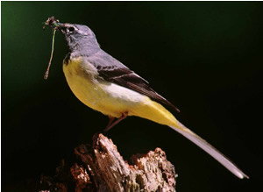
The Italian name for Grey Wagtail - Ballerina gialla, the yellow ballerina - is wonderfully appropriate for this beautiful and graceful bird. But it highlights a source of confusion - the vivid yellow of its underparts often convinces people that they're looking at Yellow Wagtail. If the back's grey, it's a Grey Wagtail (left). In the case of Yellow Wagtail (below), the male is also bright yellow underneath, but with an olive-brown back; his head is mostly yellow, too. The female is a 'faded' version of the same. Another key difference is the length of tail: Grey Wagtail's is especially long, while the Yellow Wagtail has the shortest tail of any of the wagtails.
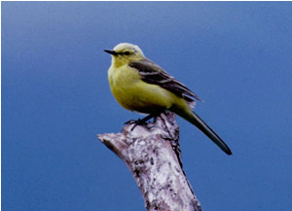
While Greys are usually found close to fast-running streams, Yellow Wagtails are more at home on arable land. With an increase in arable farming in the Upper Clun in recent years, they seem to be making a bit of a comeback. This year there were at least six pairs in the Clun and Unk valleys, and that was just the ones easily spotted from the roadside! They're particularly keen on potato fields, but in the absence of those, will take to beans, or cereal crops. When the female is incubating, the male keeps watch from a prominent perch on top of a hedge or bush, and is then quite easy to spot.
The national picture is less encouraging: the population plummeted by 73% between 1967 and 2011. Since Britain holds the entire world population of one particular race, flavissima, that's a very serious matter. The cause is believed to be changes in habitat brought about by agricultural intensification, particularly those that reduce the numbers of invertebrates available.
Many insect-eating species like Yellow Wagtails are in steep decline.
The 'windscreen test' may be a clue: when was the last time you found your windscreen plastered with insects at the end of a journey? And yet it used to be a regular thing.
BEFORE NIGHT FALLS

The nights are drawing in, and soon we'll be changing the clocks. For the birder, there are gains as well as losses when it gets dark earlier. Birds tend to be most active at the extremes of the day, dawn and dusk. The dawn chorus is well-known, but there's also a second peak in activity when the light begins to fade, and temperatures drop. It's then a race against time, with birds hastily cramming in as much food as they can to see them through the long, cold night, then making their way to the shelter of their roosts. It's no exaggeration to say that their lives depend on it - small birds especially have very few reserves, and need to feed to survive.
This means that there are excellent opportunities for the birdwatcher to see large gatherings of birds, or normally shy ones throwing caution to the wind in the race to pack in the calories. The great murmurations of Starlings typically take place at dusk, just before the birds go to roost. Sometimes you can pick up processions of Redwing and Fieldfare, group after group, all heading in the same direction. They merge into a flock, and fly on, with more birds leaving the bushes and hedgerows to join them on their twilight journey to the roost site.
Small birds huddle together for warmth, often using nestboxes or discarded containers. Wrens are a good example: there's a record of 60 packing into one nestbox! But they also build special winter nests to shelter in. These are used by as many as can squeeze inside, and the Wrens can be seen arriving in the half-hour or so before nightfall. So don't stop watching when it's getting dark - that can be the best time of all.
Photo credits: Grey Wagtail©Colin Varndell; Yellow Wagtail©Tommy Holden Magpie©Michal Matyjasik under licence creativecommons.org/licenses/by-sa/2.0/deed.en

