St Michael’s Church, Smethcott SO449993
A Wildlife Survey by Strettons Area Community Wildlife Group (SACWG)
Report by Caroline Uff
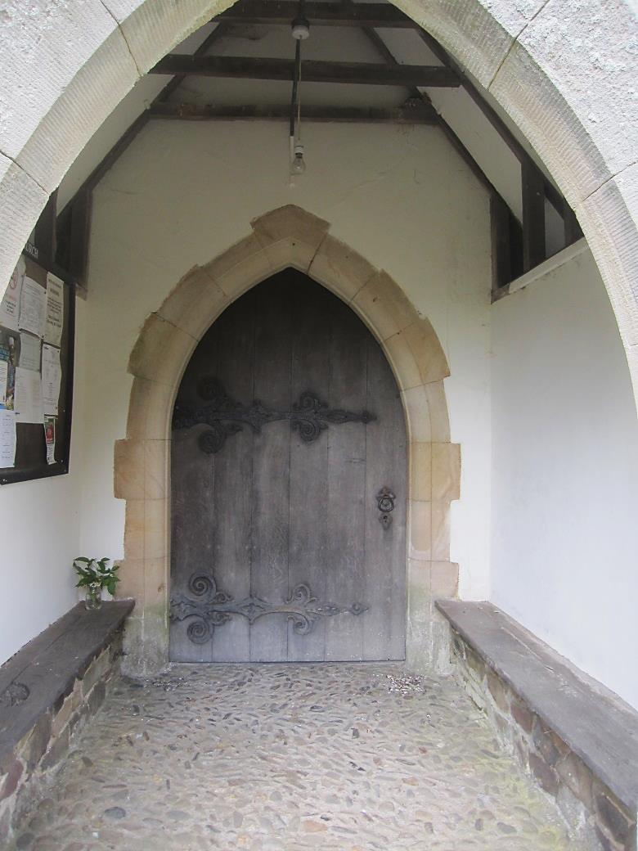
Image: C.Uff
Introduction
St Michael’s Church is situated in a very rural location at the end of a narrow lane near the village of Smethcott. It is surrounded on three sides by a hedge and has fine views across the Shropshire countryside.
Survey details
On 21/6/2014 members of SACWG assessed the site.
Ground Flora: Species were recorded from a general walkover. Ferns were also identified.
Trees: A sketch map was made of the churchyard showing the positions of the main trees.
Mammals: A baited hedgehog tunnel was left for two nights to collect mammal footprints. Tracks and signs of other mammals were also recorded. Bats were not assessed.
Birds: Any birds seen or heard either within churchyard were recorded. Those seen in flight were only recorded if it seemed likely they were using the site. Signs of nesting were noted.
Invertebrates: Species encountered/ netted were identified as far as possible.
Reptile mats: Two mats (felt roofing tiles) were left in situ for around the period of the visit to act as refuges for reptiles.
Results and comments
In all 106 species were recorded and summarised below – the full list is given in the appendix.
 | # Species recorded | Comments
Ground Flora | 52 (+2 lichens) | With the exception of some shaded areas, the grassland was mown very short little flowering. Despite this there were still signs of traditional meadow species persisting, such as bird’s-foot-trefoil, oxeye daisy, pignut, meadow vetchling and common knapweed. These species, typical of old flower rich meadows are becoming a rare sight in our countryside and should be treasured.
Trees | 14 | Predominantly native with some nice mature trees, but including some non-native species too.
Birds | 10 | It was lovely to see swallows nesting in the porch. A red kite was flying overhead.
Invertebrates | 22 | This number was low, probably due to the absence of flowering plants (nectar source) in the churchyard.
Mammals | 6 | Signs of a good number of mammals were recorded, including an active badger sett.
Reptiles | 0
Grassland Category |  | The ground flora was categorised as semi- improved neutral grassland of moderate diversity, using the churchyard companion (CfGA).
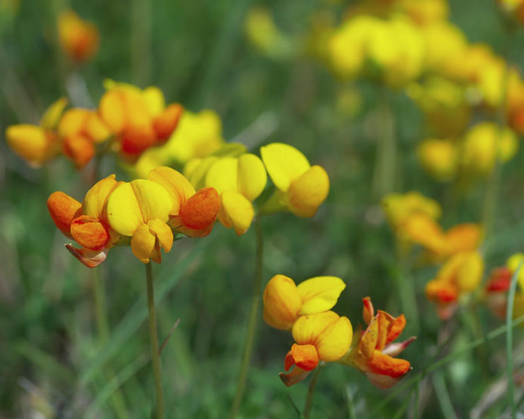
The diversity of the grassland was very good despite all being regularly mown. It appeared that the clippings had been mostly raked off which is good practice and may explain why the grassland remained so diverse.
Where access to tend graves is not a priority, there may be the opportunity to leave a section of the open species rich grassland unmown between April and mid-July to allow these increasingly uncommon meadow species to flower and set seed. This is done in many churchyards and the grassland at Smethcott certainly has the potential to provide a very attractive splash of summer colour as well as providing nectar and shelter for a range of insects, which in turn are a food source for birds and other animals. For example, the bird’s-foot trefoil pictured left was present in the grass near the entrance. Details of managing longer grassland are in the ‘managing churchyards &burial grounds’ action pack available for free download on the Caring for God’s Acre website http://www.caringforgodsacre.org.uk/
Image : http://northeastwildlife.co.uk/
The shady areas had some nice woodland species such as bluebell. A small area of long grass with some brash had been left, and although this will provide good cover for small mammals, it was quite shady and there was little of botanical interest. The taller shrub areas were clumped which provides good refuge for birds. A rough sketch map was made of the churchyard showing positions of most tree species.

Group | Plant name
Flowers | Bird's-foot-trefoil
Flowers | Bluebell
Flowers | Bramble
Flowers | Buttercup, creeping
Flowers | Buttercup, meadow
Flowers | Campion, red
Flowers | Cat's-ear
Flowers | Cleavers
Flowers | Clover, red
Flowers | Clover, white
Flowers | Chickweed, common
Flowers | Creeping Thistle
Flowers | Current
Flowers | Daisy
Flowers | Dandelions
Flowers | Dock, broad-leaved
Flowers | Dog/field Rose
Flowers | Dog's mercury
Flowers | Dog-violet, common
Flowers | Ground ivy
Flowers | Hawkeed sp
Flowers | Hogweed
Flowers | Honeysuckle
Flowers | Ivy
Flowers | Knapweed, common
Flowers | Lady's smock
Flowers | Nipplewort
Flowers | Oxeye daisy
Flowers | Pignut
Flowers | Pimpernel, scarlet
Flowers | Primrose
Flowers | Snowberry
Flowers | Sorrel, common
Flowers | Speedwell, germander
Flowers | Stinging nettle
Flowers | Stitchwort, greater
Flowers | Stitchwort, lesser
Flowers | Strawberry, barren
Flowers | Strawberry, wild
Plants recorded 2014 (English names used where possible)
Group | Plant name
Flowers | Thistle, spear
Flowers | Vetch, bush
Flowers | Vetch, common
Flowers | Vetchling, meadow
Flowers | Willowherb, broad-leaved
Flowers | Willowherb, rosebay
Flowers | Woundwort, hedge
Flowers | Yarrow
Ferns | Bracken
Grasses | Cock's foot grass
Grasses | Fescue red
Grasses | Hairgrass, wavy
Grasses | Yorkshire-fog
Lichens | Caloplaca citrina (tbc)
Lichens | Caloplaca teicholyta (tbc)
Trees and Shrubs | Blackthorn
Trees and Shrubs | Cedar sp
Trees and Shrubs | Cypress sp
Trees and Shrubs | Elder
Trees and Shrubs | Guelder Rose
Trees and Shrubs | Hawthorn
Trees and Shrubs | Hazel
Trees and Shrubs | Holly
Trees and Shrubs | Oak
Trees and Shrubs | Ornamental cherry
Trees and Shrubs | Scots Pine
Trees and Shrubs | Sycamore
Trees and Shrubs | Wych elm
Trees and Shrubs | Yew

Animals recorded 2014 (English names used where possible)
Group | Animal name
Bird | Blackbird
Bird | Chaffinch
Bird | Chiff chaff
Bird | Goldcrest
Bird | Goldfinch
Bird | House Martin
Bird | Nuthatch
Bird | Robin
Bird | Swallow (nesting)
Bird | Red Kite
Coleoptera (Beetles) | leaf beetle, Gastrophysa viridula
Diptera (Flies) | soldier fly, Sargus iridatus
Diptera (Flies) | hoverfly, Episyrphus balteatus
Diptera (Flies) | hoverfly, Eristalis pertinax
Diptera (Flies) | hoverfly, Eristalis horticola
Diptera (Flies) | fly, Yellow dung
Hymenoptera (Ants, bees and wasps) | solitary wasp, Crossocerus elongatulus
Hymenoptera (Ants, bees and wasps) | solitary wasp, Crossocerus dimidiatus
Hymenoptera (Ants, bees and wasps) | solitary wasp, Crossocerus megacephalus
Hymenoptera (Ants, bees and wasps) | solitary wasp, Ectemnius continuus
Hymenoptera (Ants, bees and wasps) | Ruby-tailed wasp, Chrysis sp
Hymenoptera (Ants, bees and wasps) | bumblebee, Buff-tailed
Hymenoptera (Ants, bees and wasps) | cuckoo bumblebee, Bombus sylvestris
Hymenoptera (Ants, bees and wasps) | bumblebee, Early
Hymenoptera (Ants, bees and wasps) | Honey bee
Hymenoptera (Ants, bees and wasps) | solitary bee, Andrena carantonica
Hymenoptera (Ants, bees and wasps) | Tree wasp
Hymenoptera (Ants, bees and wasps) | bumblebee, White-tailed
Lepidoptera (Butterflies and moths) | moth, Nettle tap
Mammal | mouse/vole (footprints)
Mammal | Mole (hills)
Mammal | Rabbit (droppings)
Mammal | Fox (droppings)
Mammal | Badger (sett)
Mites | mite, Blackthorn gall, Eriophyes similis
Snail | snail, Common garden
Snail | snail, White lipped garden

