St. Margaret’s Church, Acton Scott SO453894
A Wildlife Survey by Strettons Area Community Wildlife Group (SACWG)
Report by Caroline Uff
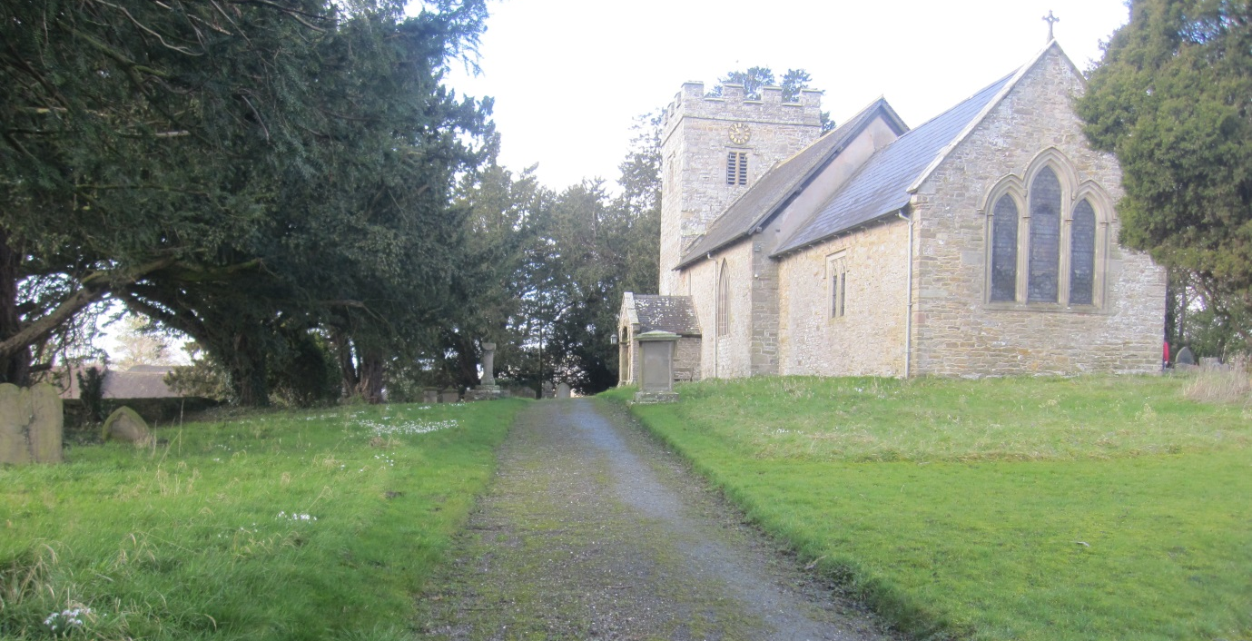
Image: C.Uff
Introduction
St. Margaret’s Church is situated off a quiet lane on the edge of the rural village of Acton Scott. The churchyard is bounded by stone walls and has both open and shady areas. The area by the entrance and the path sides are kept mown, but much of the churchyard is left uncut to flower and seed freely. A previous churchyard survey was carried out in 2000 by John Thompson.
Survey details
On 4/6/2014, member of SACWG assessed the site. Heavy rain limited the survey and meant that most of the data collected related to the plants.
Ground Flora: Species were recorded from a general walkover. Diversity was assessed in one or two quadrats (2x2m). This was used to trial a ‘churchyard companion’ being developed by CfGA which aimed to classify the type of grassland present. Ferns on the walls were also identified.
Trees: The existing map from 2000 was updated. Species were listed and measured.
Mammals: a baited hedgehog tunnel was left for two nights to collect mammal footprints. Tracks and signs of other mammals were also recorded. Bats were not assessed.
Birds: Any birds seen or heard within churchyard were recorded. Those seen in flight were only recorded if it seemed likely they were using the site. Signs of nesting were noted.
Invertebrates: Any species encountered within the churchyard (sweeping and beating) were identified as far as possible, but wet weather reduced insect activity.
Results and comments
Ninety eight species were recorded – the full list is given at the end. The heavy rain meant that invertebrates were hard to find. This was disappointing as this churchyard had the highest number of plant species of all the burial ground surveyed and is likely therefore to support a very diverse invertebrate fauna species.
 | # Species recorded | Comments
Ground Flora | 70 | This churchyard was the most diverse of all the churchyards surveyed in the area - even in the winter it was a carpeted in snowdrops. It is a lovely example of how churchyards retain old flower rich grasslands that once common-place across the country. Worthy of note were bird’s foot trefoil, mouse-ear hawkweed, pignut, St.John’s-wort, oxeye daisy, and common knapweed. These wildflowers are indicators of traditional species rich lowland grasslands which are becoming uncommon nationally. Some nice species recorded in 2000 were not picked up, but may still be present including, ladies bedstraw, ladies mantle and wood sorrel. The more shady areas had typical old woodland species such as bluebell and wood speedwell.
Trees | 9 | The most striking feature was the large yew trees throughout the churchyard – one magnificent specimen with a girth of almost 7.6m. Otherwise there were mostly native trees but with some ornamental shrubs which couldn’t be identified near the entrance. More information on the yews of Acton Scott can be found on the ancient yew group website http://www.ancient-yew.org/
Birds | 13 | The churchyard supported good numbers of birds including nesting mistle thrush.
Insects | 5 | Wet weather meant very few invertebrates seen, but great potential.
Mammals | 1 | Vole/mouse footprints were found in the tunnel, but could not be identified to species level
Reptiles | 0
Grassland Type |  | The ground flora was categorised as neutral lowland grassland using the churchyard companion (CfGA). There were 21 species recorded from a single quadrat which meant that the grassland was in the top, species rich, category.
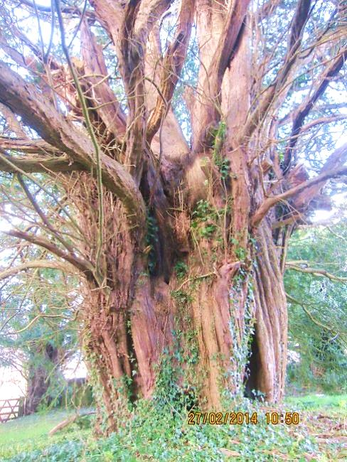
Impressive ancient yew, mistle thrush and wild meadow flowers

Image above and right by: http://northeastwildlife.co.uk/
Image: C.Uff
The previous recommendations by J. Thompson remain appropriate and suggested a cut in mid-July and again in late September/Oct would be the ideal management. The grassland was very tussocky in places, indicating that it had not been cut at all in these areas. Leaving some areas of longer grass to flower and seed is very important for wildlife as well as providing a colourful display, but leaving uncut over years will eventually lead to a decline in quality as spring flowers and other delicate species will struggle. It is important to removed grass cuttings to maintain the botanical species richness.
Details of managing longer grassland can be downloaded for free from the ‘managing churchyards &burial grounds’ action pack available from the Caring for God’s Acre website http://www.caringforgodsacre.org.uk/
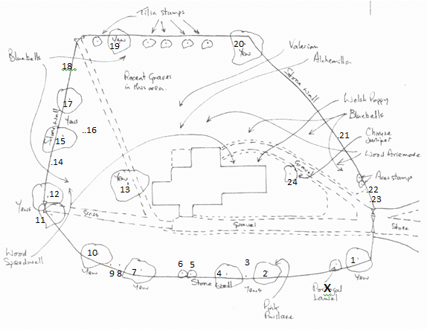
John Thompson’s sketch map from 2000 remains applicable today. Notes on the trees have however been added in the table below.
ref | Name | Est Height (m) | circumference (cm) | Est Spread (m) | Notes
1 | Yew | 8 | 264 | 9 | Many dead branches
2 | Yew | 14 | 378 | 15 | Top removed long ago
3 | Yew | 1 | 15 | 50
4 | Yew | 14 | 342 | 15
5 | Yew | 1.5 | 20 | 2.5
6 | Yew | 1.5 | 30 | 2.5
7 | Yew | 14 | 243 | 17 | 4 large bores. Topped. Ivy
8 | Sycamore | 2 | 8 | 1.5 | Growing in wall. Remove?
9 | Holly | 1.5 | 5 | 2 | Several saplings. Ivy covered
10 | Yew | 24 | 711 | 14 | 8 boles. Magnificent
11 | Yew (incl  2 dead stumps) | 24 | 711 | 11 | Epicormic growth on trunk. Many branches removed.
12 | Yew | 22 | 511 | 20 | Epicormic growth on trunk.
13 | Yew | 30 | 757 | 16 | Magnificent. Veteran?
14 | Laurel, Cherry | 2 | 15 | 5
15 | Yew | 18 | Not done | 5 | Ivy covered
16 | Elder | Small |  |  | several
17 | Yew | Large | Not done | Not done
18 | Ash | 30 | 94 (1 bore) | 8
19 | Yew | Medium | Not done | Not done
20 | Yew | V large | Not done | Not done | Ivy covered
21 | Quince | 1 |  | 1
22 | Unknonwn shrub | 1
23 | Laurel, ? Portugal | 1
24 | Juniper, Chinese | 18 | 185 | 5 | Half hacked away but Ok

Animals recorded 2014 (English names used where possible)
Group | Animal name
Bird | Blackbird
Bird | Blue tit
Bird | Carrion crow
Bird | Chaffinch
Bird | Collared Dove
Bird | Common Whitethroat
Bird | Dunnock
Bird | Jackdaw
Bird | Robin
Bird | Swallow
Bird | Mistle Thrush (nesting)
Bird | Wood pigeon
Bird | Wren
Coleoptera (Beetles) | ground beetle, Nebria brevicollis
Hymenoptera (Ants, bees and wasps) | Honey Bee
Lepidoptera (Butterflies and moths) | micromoth, Adela degeerella
Lepidoptera (Butterflies and moths) | moth, nettle tap
Lepidoptera (Butterflies and moths) | moth, silver-ground carpet
Mammal | mouse/vole (footprints)

Plants recorded 2014 (English names used where possible)
Group | Plant name
Flowers | Bird's-foot-trefoil
Flowers | Bluebell
Flowers | Bramble
Flowers | Bugle
Flowers | Buttercup, bulbous
Flowers | Buttercup, creeping
Flowers | Buttercup, meadow
Flowers | Campion, red
Flowers | Cat's-ear
Flowers | Celandine, lesser
Flowers | Chervil, rough
Flowers | Cleavers
Flowers | Clover, red
Flowers | Clover, white
Flowers | Cow parsley
Flowers | Daisy
Flowers | Dandelions
Flowers | Dog's mercury
Flowers | Dog-violet, common
Flowers | Field/wood forget-me-not
Flowers | Foxglove
Flowers | Garlic mustard
Flowers | Ground elder
Flowers | Ground ivy
Flowers | Hawkbit, rough
Flowers | Hawkweed, mouse-ear
Flowers | Herb-Robert
Flowers | Hogweed
Flowers | Ivy
Flowers | Knapweed, common
Flowers | Lord's-and-ladies
Flowers | Meadow-sweet
Flowers | Mouse-ear, common
Flowers | Nipplewort
Flowers | Oxeye daisy
Flowers | Pignut
Flowers | Plantain, broad-leaved
Flowers | Plantain, ribwort
Flowers | Poppy, Welsh
Flowers | Primrose
Flowers | Purslane, pink
Group | Plant name
Flowers | Ragwort
Flowers | Selfheal
Flowers | Snowdrop
Flowers | Sorrel, common
Flowers | Sow Thistle, prickly
Flowers | Speedwell, germander
Flowers | Speedwell, thyme-leaved
Flowers | Speedwell, wood
Flowers | St. John's-wort, square-stemmed
Flowers | Stinging nettle
Flowers | Strawberry, barren
Flowers | Strawberry, wild
Flowers | Thistle, marsh
Flowers | Toadflax, ivy-leaved
Flowers | Vetch, bush
Flowers | Vetchling, meadow
Flowers | Wavy bittercress
Flowers | Wood avens
Flowers | Wood-rush, field
Flowers | Woundwort, hedge
Flowers | Yarrow
Ferns | Hart's tongue
Ferns | Male fern
Grasses | Cock's foot grass
Grasses | Fescue red
Grasses | Foxtail, meadow
Grasses | Oat-grass, false
Grasses | Sweet Vernal Grass
Grasses | Yorkshire-fog
Trees and Shrubs | Ash
Trees and Shrubs | Chinese juniper
Trees and Shrubs | Elder
Trees and Shrubs | Holly
Trees and Shrubs | Laurel, Cherry
Trees and Shrubs | Laurel, Portuguese
Trees and Shrubs | Quince
Trees and Shrubs | Sycamore
Trees and Shrubs | Yew

