St. James’ Church, Cardington SO506951
A Wildlife Survey by Strettons Area Community Wildlife Group (SACWG)
Report by Caroline Uff
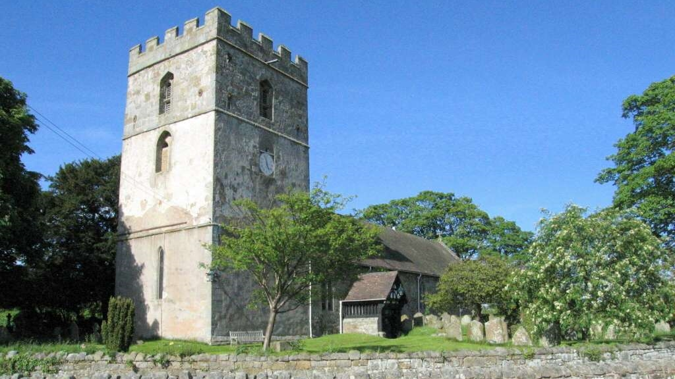
Introduction
St. James’ Church is situated in the centre of the rural village of Cardington, bounded by roads and private houses.
Survey details
On 11th July,2014, members of SACWG were joined by Members of Caring for God’s Acre (CfGA) as well as several visiting specialists, Hilary Wallace (botany), Keith Fowler, (hemiptera) and Jim Cresswell (general invertebrates) to assess the site.
Ground Flora: Species were recorded from a general walkover. Diversity was assessed in one or two quadrats (2x2m). Information collected was used to trial a ‘churchyard companion’ being developed by CfGA http://www.caringforgodsacre.org.uk/ which aimed to classify the type of grassland present.
Trees: As SACWG were unaware of existing surveys, the trees of the churchyard were both listed and mapped
Mammals: Tracks and signs of mammals were recorded. Bats were not assessed.
Birds: Any birds seen or heard within churchyard were recorded. Those seen in flight were only recorded if it seemed likely they were using the site. Signs of nesting were noted.
Invertebrates: Any species encountered within the churchyard were identified as far as possible. Sweep nets and beating trays were used.
Results and comments
143 species were recorded – the full list is given at the end. The churchyard had open areas, but there were also shaded/wooded areas. Some areas of grassland were left uncut to allow flowering. A sketch map was made of the churchyard and main tree species mapped.
 | # Species recorded | Comments
Ground Flora | 52 | In the open areas, several species indicative of old meadows were present including yellow oat grass and oxeye daisy. The churchyard also had some nice woodland flora with bluebells. There was a patch of pink purslane, which although non-native is not particularly invasive, and also a patch of Japanese knotweed which is invasive and should be controlled.
Trees | 22 | There was a mixture of native and exotic trees on the site, including a magnificent ancient yew with a girth of 4m20.
Birds | 6 | Swifts were recorded overhead, and although nesting not confirmed, churches are often used as swift nest sites.
Invertebrates | 60 | A very good list of species were using the site which was great to see, including the nationally notable solitary bee, Stelis punctulatissima and its host, the carder bee Anthidium manicatum.
Mammals | 3 | A dead field vole was found and mole hills present. Bats were said to be present by the warden, but were not surveyed.
Grassland Type |  | The grassland was categorised as semi improved neutral grassland of moderate diversity, using the churchyard companion (CfGA)

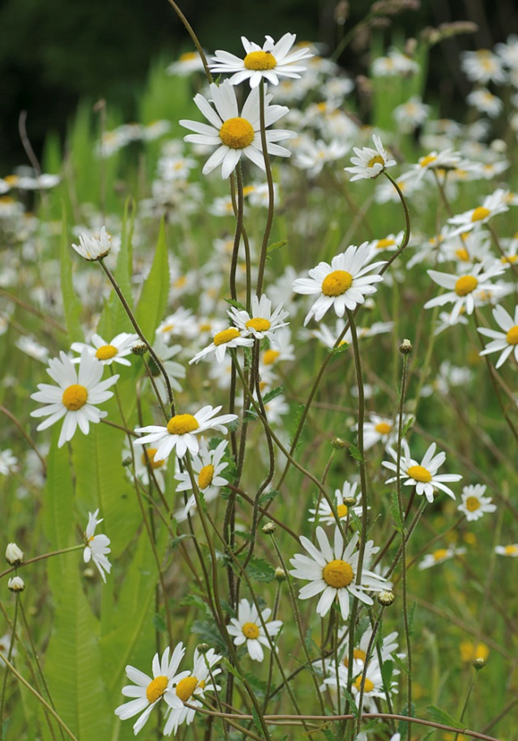
A sunny section of grassland along the path edge was left uncut and provided a beautiful display of oxeye daisy interspersed with the naturalised orange hawkweed. This section was one of the more botanically diverse sections of the churchyard and will be an important nectar source for a wide range of invertebrates including the rare solitary bee, Stelis punctulatissima. Leaving patches of long grass to flower is important for wildlife, but botanical diversity can also be maintained in shorter areas providing clippings are removed. Information on managing grassland can be downloaded for free from the ‘managing churchyards &burial grounds action pack’ on the Caring for God’s Acre website http://www.caringforgodsacre.org.uk/
The trees and shrubs provide shelter, food and nest sites for a variety of birds, but it is possible that the building itself may also provide nest sites for swifts. Swifts are a species of conservation concern as their numbers have declined rapidly in recent years. Loss of nest sites due to modern building techniques is thought to be a contributing factor, and churches such as this are often valuable nesting sites. It is important to look after these sites and ask for advice if needed. The Shropshire swift group can be contacted at http://www.shropshireswifts.org.uk/
ref | Name | Est height (m) | Circumfer-ence (m)
1 | Horse Chestnut | 40 | 4.50
2 | Beech | 45 | 2.30
3 | Yew | 30 | 2.05
4 | Lime | 40 | 2.30
5 | Lilac | 6 | 5 boles
6 | Copper Beech | 40+ | 3.00
7 | Yew (common) | 30 | 2 boles
8 | Yew (common) | 35 | 2 boles
9 | Yew (common) | 40 | 5 boles
10 | Yew (Irish) | 25 | 7 boles
11 | Yew (Irish) | 20 | 12 boles
12 | Yew (Irish) | 15 | 12 boles
13 | Yew (Irish) | 15 | 12 boles
14 | Monkey Puzzle | 40 | 2.10
15 | Lawson’s cypress? | 30 | 2.40
16 | Norway Spruce | 45 | 2.20
17 | Unknown | 2
18 | Silver Birch | 15
19 | Lawson’s cypress? |  | 1.90
20 | Holly | 18 | 4 boles
21 | Yew (common) | 35 | 4.20 magnificant
22 | Yew (common) | 20 | ?
23 | Lilac | 4 | Many boles
24 | Laburnum (+ivy) | 10 | Many boles
25 | Maple | 40 | 2.40
26 | Maple | 40 | 2.60
27 | Maple | 40 | 2.30
28 | Maple | 40 | 2 boles
29 | Holly (variegated) | 2
30 | Holly (variegated) | 4
31 | Lilac | 3 | 3 boles
32 | Rose and viburnum
33 | Sycamore | 40 | 4.70
34 | Cherry (Ornamental) | 1.5
35 | Cherry | 5
36 | Holly | 1.5 | Many boles
37 | Cherry | 4 | 0.95
38 | Cherry | 4 | 0.95
39 | Rowan | 8 | 0.6
40 | Unknown ?Sorbus | 1 | Many boles
41 | Yew (yellow) | 1.5
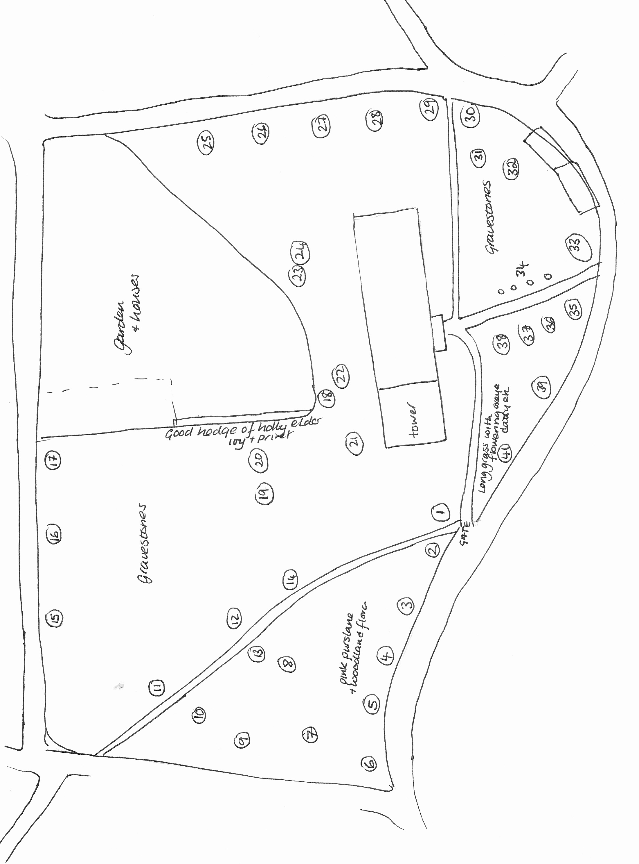
Plants recorded 2014 (English names used where possible)

Group | Plant name
Flowers | Bluebell
Flowers | Bramble
Flowers | Cat's-ear
Flowers | Cleavers
Flowers | Clover, white
Flowers | Cow parsley
Flowers | Daisy
Flowers | Dandelions
Flowers | Dog-violet, common
Flowers | Field/wood forget-me-not
Flowers | Fox and cubs
Flowers | Garlic mustard
Flowers | Herb-Robert
Flowers | Hogweed
Flowers | Honeysuckle
Flowers | Ivy
Flowers | Japanese Knotweed
Flowers | Nipplewort
Flowers | Oxeye daisy
Flowers | Plantain, broad-leaved
Flowers | Plantain, ribwort
Flowers | Purslane, pink
Flowers | Ragwort
Flowers | Selfheal
Flowers | Sorrel, common
Flowers | Sow Thistle, prickly
Flowers | Sow Thistle, smooth
Flowers | Speedwell, germander
Flowers | Speedwell, wood
Flowers | Stinging nettle
Flowers | Strawberry, barren
Flowers | Strawberry, wild
Flowers | Trefoil, lesser
Flowers | Vetch, bush
Flowers | Willowherb, rosebay
Flowers | Wood avens
Flowers | Woundwort, hedge
Flowers | Yarrow
Group | Plant name
Grasses | Bent grass
Grasses | Brome, barren
Grasses | Cock's foot grass
Grasses | Couch grass
Grasses | Crested Dog's Tail
Grasses | Fescue red
Grasses | Hairgrass, tufted
Grasses | Meadow grass, smooth
Grasses | Oat-grass, false
Grasses | Oat-grass, yellow
Grasses | Rye grass, perennial
Grasses | Sweet Vernal Grass
Grasses | Yorkshire-fog
Mosses | Rhytidiadelphus squarrosus
Trees and Shrubs | Beech
Trees and Shrubs | Cherry
Trees and Shrubs | Copper Beech
Trees and Shrubs | Cypress sp
Trees and Shrubs | Elder
Trees and Shrubs | Holly
Trees and Shrubs | Horse Chestnut
Trees and Shrubs | Laburnum
Trees and Shrubs | Lilac
Trees and Shrubs | Lime
Trees and Shrubs | Maple field
Trees and Shrubs | Monkey puzzle
Trees and Shrubs | Ornamental cherry
Trees and Shrubs | Privet
Trees and Shrubs | Rose – field
Trees and Shrubs | Rowan
Trees and Shrubs | Silver Birch
Trees and Shrubs | Spruce, Norway
Trees and Shrubs | Sycamore
Trees and Shrubs | Viburnum
Trees and Shrubs | Yew (Irish and English)

Animals recorded 2014 (English names used where possible)
Group | Animal Name
Bird | Blue tit
Bird | Carrion crow
Bird | Greenfinch
Bird | Robin
Bird | Swift
Bird | Wood pigeon
Coleoptera (Beetles) | Beetle
Coleoptera (Beetles) | Beetle
Coleoptera (Beetles) | ladybird, 14-spot
Coleoptera (Beetles) | ladybird, 2-spot
Coleoptera (Beetles) | soldier beetle
Diptera (Flies) | Hoverfly
Diptera (Flies) | Hoverfly
Diptera (Flies) | Hoverfly
Diptera (Flies) | Hoverfly
Diptera (Flies) | Hoverfly
Diptera (Flies) | Hoverfly
Diptera (Flies) | Hoverfly
Diptera (Flies) | soldier fly
Earwig | Common earwig
Hemiptera (bugs) | Alebra wahlbergi
Hemiptera (bugs) | Anthocoris confusus
Hemiptera (bugs) | Anthocoris nemorum
Hemiptera (bugs) | Aphrodes makarovi
Hemiptera (bugs) | Aphrophora alni
Hemiptera (bugs) | Bryocoris pteridis
Hemiptera (bugs) | Campyloneura virgula
Hemiptera (bugs) | Common froghopper
Hemiptera (bugs) | Eupteryx aurata
Hemiptera (bugs) | Eupteryx stachydearum
Hemiptera (bugs) | Euscelis incisus
Hemiptera (bugs) | Fagocyba cruenta
Hemiptera (bugs) | Liocoris tripustulatus
Hemiptera (bugs) | Lygocoris pabulinus
Hemiptera (bugs) | Monalocoris filicis
Hemiptera (bugs) | Oncopsis subangulata
Hemiptera (bugs) | Oncopsis tristis
Hemiptera (bugs) | Orthops campestris
Hemiptera (bugs) | Shieldbug, green
Hemiptera (bugs) | Trioza urticae
Hymenoptera (Ants, bees and wasps) | ant, Formica fusca
Hymenoptera (Ants, bees and wasps) | ant, Myrmica rubra
Hymenoptera (Ants, bees and wasps) | bumblebee, common carder
Hymenoptera (Ants, bees and wasps) | bumblebee, Red-tailed
Hymenoptera (Ants, bees and wasps) | Honey Bee
Hymenoptera (Ants, bees and wasps) | Anthidium manicatum (stelis host)
Hymenoptera (Ants, bees and wasps) | leaf cutter bee, Megochile willughbiella
Hymenoptera (Ants, bees and wasps) | mining bee, Andrena minutula
Hymenoptera (Ants, bees and wasps) | mining bee, Hylaeus communis
Hymenoptera (Ants, bees and wasps) | mining bee, Lasioglossum cupromicans
Hymenoptera (Ants, bees and wasps) | solitary bee, Stelis punctulatissima (Nb)
Hymenoptera (Ants, bees and wasps) | solitary wasp, Ancistrocerus parietinus
Hymenoptera (Ants, bees and wasps) | solitary wasp, Crossocerus podagricus
Hymenoptera (Ants, bees and wasps) | solitary wasp, Sapyga quinquepunctata
Lepidoptera (Butterflies and moths) | butterfly, speckled wood
Lepidoptera (Butterflies and moths) | butterfly, comma
Lepidoptera (Butterflies and moths) | butterfly, large white
Lepidoptera (Butterflies and moths) | butterfly, meadow brown
Lepidoptera (Butterflies and moths) | butterfly, ringlet
Lepidoptera (Butterflies and moths) | butterfly, small tortoiseshell
Lepidoptera (Butterflies and moths) | butterfly, small white
Lepidoptera (Butterflies and moths) | micromoth, Celypha striana
Lepidoptera (Butterflies and moths) | micromoth, Pseudargyrotoza conwagana
Lepidoptera (Butterflies and moths) | moth, humming-bird hawkmoth
Lepidoptera (Butterflies and moths) | moth, silver-Y
Psocoptera (Barkfly) | barkfly, Graphopsocus cruciatus
Mammal | Bat (reported by warden)
Mammal | field vole (dead)
Mammal | Mole (hill)

