St. Andrew’s Church, Hope Bowdler SO475924
A Wildlife Survey by Strettons Area Community Wildlife Group (SACWG)
Report by Caroline Uff
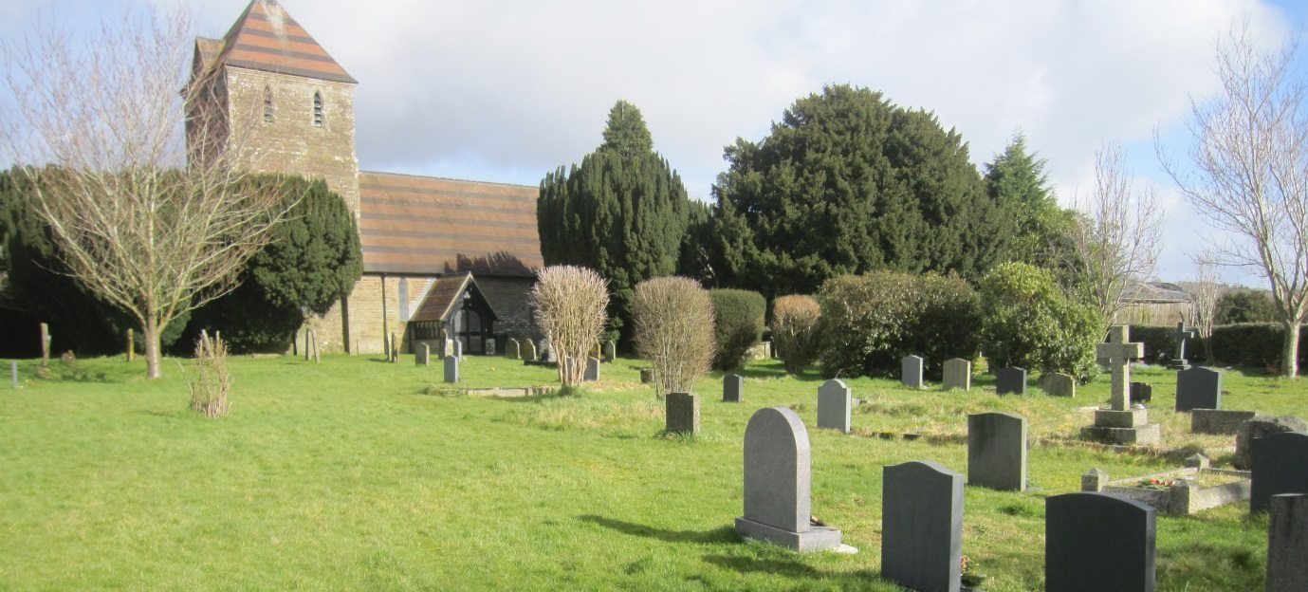
Image: C.Uff

Introduction
St. Andrew’s Church is situated in the centre of the village of Hope Bowdler. It has quite a large churchyard, largely surrounded by hedges with only a short section of wall. Two previous surveys were available. A vegetation survey by John Thompson in 1999, and a tree survey by Peter Norman in 2000.
Survey details
On 11th July,2014, members of SACWG were joined by Members of Caring for God’s Acre as well as several visiting specialists, Hilary Wallace (botany), Keith Fowler, (hemiptera) and Jim Cresswell (general invertebrates) to assess the site. An earlier visit 4th June was abandoned due to heavy rain.
Flora: Species were recorded from a general walkover. Diversity was assessed in one or two quadrats (2x2m). Data were used to trial a ‘churchyard companion’ being developed by CfGA which aimed to classify the type of grassland present. Ferns on the walls and trees were also identified and the existing maps from 1999 and 2000 were checked.
Mammals: a baited hedgehog tunnel was left for two nights to collect mammal footprints. Tracks and signs of other mammals were also recorded. Bats were not assessed.
Birds: Any birds seen or heard within churchyard were recorded. Those seen in flight were only recorded if it seemed likely they were using the site. Signs of nesting were noted.
Invertebrates: Any species encountered or netted within the churchyard were identified as far as possible.
Reptile mats: Two mats (felt roofing tiles) were left in situ for approx 1 month around the period of the visit to act as refuges for reptiles.
Results and comments
One hundred and twenty one species were recorded – the full list is given at the end. The churchyard has both open and shaded areas, with the main path being densely shaded by an avenue of Yew trees. It was good to see an area of grassland in the southern section which was left uncut to allow flowering.
 | # Species noted | Comments
Ground Flora | 53 | Although mostly mown quite short it is still possible to identify some moderately diverse areas of grassland which contain species typical of old flower rich meadows. Such grasslands are becoming increasing rare in our countryside. Species worthy of note include harebell, lady’s bedstraw, mouse-ear hawkweed, meadow vetchling and yellow oat grass. The position of some of these species are shown on the map
Trees and shrubs | 10 | The over-arching avenue of Irish yews lining the path is very striking. There is a healthy Holly Hedge. The Lawson’s cypress hedge along the western boundary was noted in 2000 by Norman to be 6m high and unmanageable. It has now been reduced to a well maintained 1m high hedge. There appear to have been several recent plantings of non-native ornamental shrubs.
Birds | 9 | Swifts were active around the church tower and presumed to have nested as there appeared to be a dead fledgling caught up near the top of the tower. There were also at least 3 house sparrow nests.
Insects etc. | 48 | There were 2 observations worthy of note. There was a communal nest of the solitary mining bee, Andrena carantonica on the bank by the path to the lychgate. Nearby on a Cypress tree was a Juniper Shieldbug. This bug used to be very rare in UK, but is increasing its range across the country and often found, as this one, on cypress trees.
Mammals | 1 | Although it was not possible to be 100% certain, the footprints collected in the tunnel appeared to belong to a polecat.
Reptiles | 0
Grassland Type |  | Semi-improved neutral grassland of moderate species richness using criteria from CfGA’s churchyard companion.
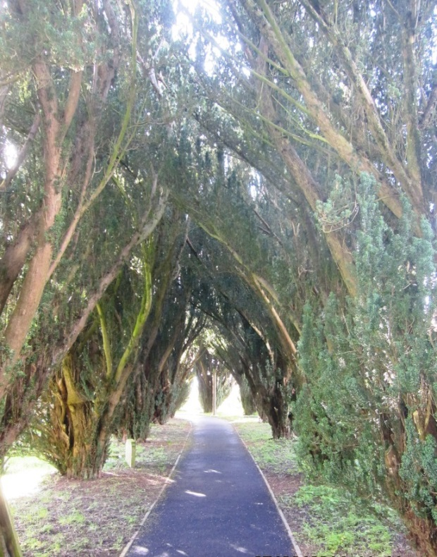
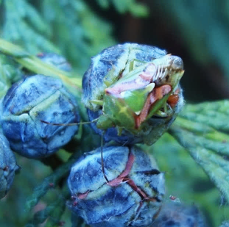
Image: M. Furber & W. Putter

Image: C.Uff

Avenue of Irish Yew and the uncommon juniper shield bug
John Thompson’s sketch map (below) from 1999 remains relevant today. Many of the nice grassland species such as harebell, ladies bedstraw and heath bedstraw still survive despite regular mowing. Providing grass clippings are removed these species are likely to persist. However, these much loved and increasingly uncommon meadow species would benefit and may even spread if allowed to flower and set seed some years.
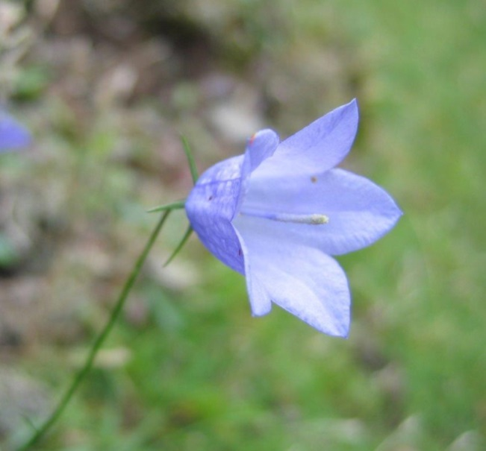
A small sunny area in the southern part of the churchyard was left uncut and this had good grassland diversity and included indicator species of old meadows. It appeared that this section was left uncut all year round, providing seed heads for birds and over-wintering insects. If it is felt that this patch of grassland is starting to get more course (as sometimes happens with repeated late or no cuts), an earlier cut every few years will not harm the plants which are perennials. Traditional hay meadows, would have been cut varying times from July onwards, depending upon the weather. Management advice given in Thompson’s 1999 survey is still appropriate. Details of managing longer grassland can also be downloaded for free from the ‘managing churchyards &burial grounds’ action pack available from the Caring for God’s Acre website http://www.caringforgodsacre.org.uk/
Leaves of harebell were found in a mown area of grassland. Image C.Uff
In the south eastern section (marked as ‘3’ on the map) there have been a number of new, mainly exotic shrubs planted which are around 2-3 m high. Shrubs planted in groups provide good shelter, food and nest sites for birds such as the house sparrows recorded here.
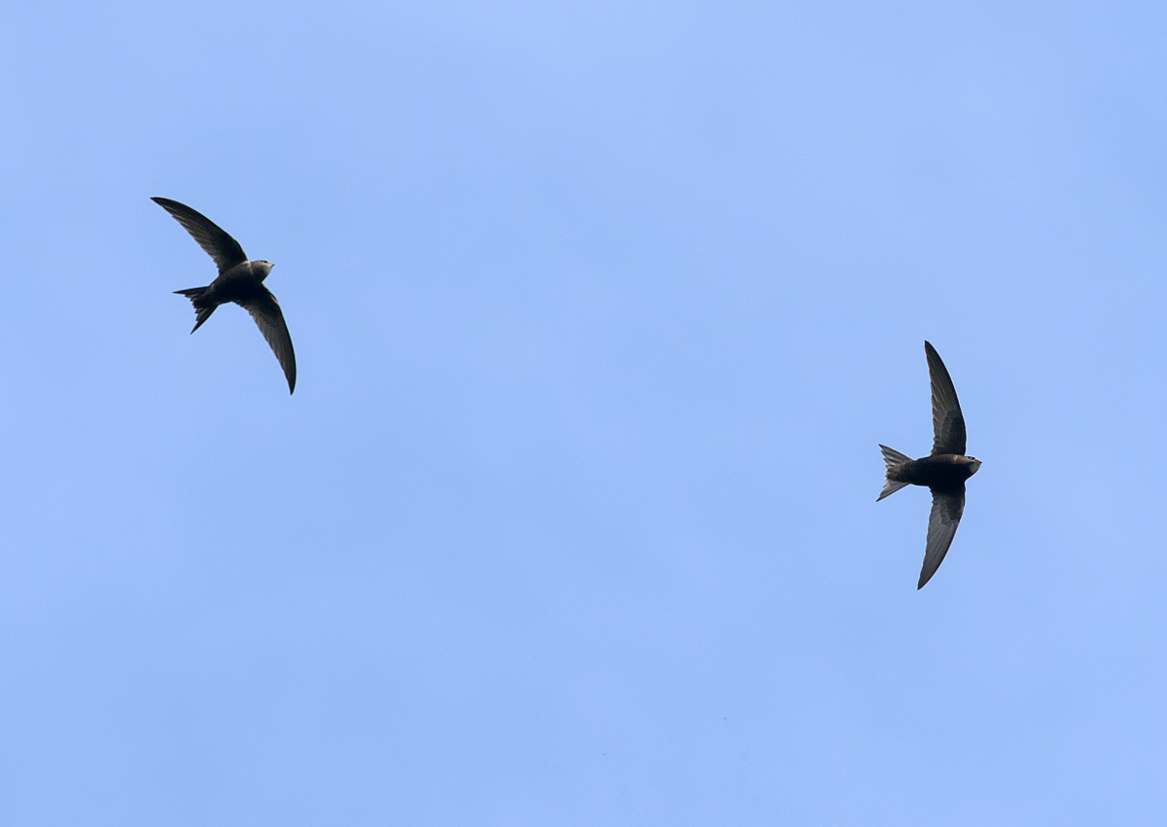
Image: http://northeastwildlife.co.uk/

Swifts are a species of conservation concern as their numbers have declined rapidly in recent years. Loss of nest sites due to modern building techniques is thought to be a contributing factor, and churches such as Hope Bowdler are often valuable nesting sites. It is important to look after these sites and ask for advice if any building works are planned for the roof - the Shropshire swift group can be contacted at http://www.shropshireswifts.org.uk/

Plants recorded 2014 (English names used where possible)
Group | Plant name
Ferns | Male fern
Flowers | Bedstraw, lady's
Flowers | Bramble
Flowers | Buttercup, creeping
Flowers | Cat's-ear
Flowers | Celandine, greater
Flowers | Cleavers
Flowers | Clover, white
Flowers | Cow parsley
Flowers | Daisy
Flowers | Dandelions
Flowers | Fox and cubs
Flowers | Garlic mustard
Flowers | Ground elder
Flowers | Ground ivy
Flowers | Harebell
Flowers | Hawkbit, autumn
Flowers | Hawkweed, mouse-ear
Flowers | Herb-Robert
Flowers | Hogweed
Flowers | Honesty
Flowers | Ivy
Flowers | Mallow, common/musk
Flowers | Mouse-ear, common
Flowers | Nipplewort
Flowers | Oxeye daisy
Flowers | Plantain, ribwort
Flowers | Primrose
Flowers | Selfheal
Flowers | Sorrel, common
Flowers | Sow Thistle, smooth
Flowers | Speedwell, germander
Flowers | Stinging nettle
Flowers | Strawberry, barren
Flowers | Strawberry, wild
Flowers | Vetch, common
Flowers | Vetchling, meadow
Flowers | Wood avens
Flowers | Wood-rush, field
Flowers | Yarrow
Group | Plant name
Grasses | Bent grass
Grasses | Brome, barren
Grasses | Cock's foot grass
Grasses | Fescue red
Grasses | Foxtail, meadow
Grasses | Meadow grass, smooth
Grasses | Oat-grass, false
Grasses | Oat-grass, yellow
Grasses | Rye grass, perennial
Grasses | Sweet Vernal Grass
Grasses | Yorkshire-fog
Mosses | several
Trees and Shrubs | Berberis
Trees and Shrubs | Cherry
Trees and Shrubs | Cypress, Lawsons
Trees and Shrubs | Elder
Trees and Shrubs | Hawthorn
Trees and Shrubs | Holly
Trees and Shrubs | Philadelphus
Trees and Shrubs | Rhododendron
Trees and Shrubs | Yew (Irish and English)

Animals recorded 2014 (English names used where possible)
Group | Animal name
Bird | Goldfinch
Bird | Great tit
Bird | House Martin
Bird | House Sparrow (3+ nests)
Bird | Jackdaw
Bird | Starling
Bird | Swallow
Bird | Swift (nest)
Bird | Wood pigeon
Mammal | Polecat (footprints)
Arachnids (Spiders etc) | Garden spider
Arachnids (Spiders etc) | harvestman, Dicranopalpus ramosus
Coleoptera (Beetles) | soldier beetle, Rhagonycha fulva
Coleoptera (Beetles) | beetle, Anthrenus fuscus
Coleoptera (Beetles) | beetle, Lagria hirta
Coleoptera (Beetles) | beetle, Oedemira nobilis
Coleoptera (Beetles) | ladybird, 14-spot
Diptera (Flies) | soldier fly, Chloromyia formosa
Diptera (Flies) | soldier fly, Pachygaster leachii
Diptera (Flies) | hoverfly, Helophilus pendulus
Diptera (Flies) | hoverfly, Syritta pipiens
Diptera (Flies) | hoverfly, Episyrphus balteatus
Hemiptera (bugs) | Anthocoris nemorum
Hemiptera (bugs) | Common froghopper
Hemiptera (bugs) | Cicadula sp.
Hemiptera (bugs) | Euscelis incisus
Hemiptera (bugs) | Megophthalmus scabripennis
Hemiptera (bugs) | Acetropis gimmerthalii
Hemiptera (bugs) | Campyloneura virgula
Hemiptera (bugs) | Closterotomus norwegicus
Hemiptera (bugs) | Liocoris tripustulatus
Hemiptera (bugs) | Stenodema calcarata
Hemiptera (bugs) | Stenotus binotatus
Hemiptera (bugs) | Cacopsylla peregrina
Hemiptera (bugs) | shieldbug, Green
Hemiptera (bugs) | shieldbug, Juniper
Hymenoptera (Ants, bees and wasps) | solitary bee
Hymenoptera (Ants, bees and wasps) | solitary wasp, Ancistrocerus nigricornis
Hymenoptera (Ants, bees and wasps) | solitary wasp, Crossocerus podagricus
Hymenoptera (Ants, bees and wasps) | solitary wasp, Passaloecus singularis
Hymenoptera (Ants, bees and wasps) | mining bee, Lasioglossum calceatum
Hymenoptera (Ants, bees and wasps) | mining bee, Lasioglossum cupromicans
Hymenoptera (Ants, bees and wasps) | ant, Myrmica scabrinodis
Hymenoptera (Ants, bees and wasps) | ant, Myrmica ruginodis
Hymenoptera (Ants, bees and wasps) | bumblebee, common carder
Hymenoptera (Ants, bees and wasps) | Common wasp
Hymenoptera (Ants, bees and wasps) | Tree wasp
Hymenoptera (Ants, bees and wasps) | ant,Yellow meadow
Lepidoptera (Butterflies and moths) | micromoth, Agriphila straminella
Lepidoptera (Butterflies and moths) | butterfly, comma
Lepidoptera (Butterflies and moths) | butterfly, gatekeeper
Lepidoptera (Butterflies and moths) | butterfly, large white
Lepidoptera (Butterflies and moths) | butterfly, meadow brown
Lepidoptera (Butterflies and moths) | butterfly, ringlet
Lepidoptera (Butterflies and moths) | butterfly, small tortoiseshell
Lepidoptera (Butterflies and moths) | moth, marbled beauty caterpillar (a lichen feeder)
Orthoptera (Grasshoppers etc.) | grasshopper, Common green

