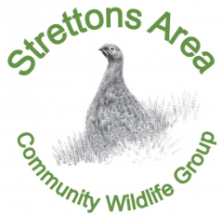
Stretton Area Community Wildlife Group
ANNUAL PUBLIC MEETING
Tuesday 27 February 2024
Time: Doors open 7pm, Meeting starts at 7.30pm
Venue: All Stretton Village Hall

AGENDA

- Apologies
- Minutes of the last AGM
- Chair’s report
- Treasurer’s report
- Election of officers
- AOB
- Project reports:
- Bats  - Botanical surveys  - Butterflies  - Crayfish  - Community tree planting  - Curlew and Lapwing | - Dormice  - Stretton wetlands  - Red grouse and Dippers  - Stretton meadows  - Swifts

- Stepping Stones – an update on new developments
- Project sign up

