RED KITE

After several successful seasons there was a marked drop in occupancy this year: five long-standing nest sites were vacant. A site in the Unk valley which had supported two nests a short distance apart saw only one short-lived attempt. A female from an early recolonizing nest in the Teme Valley had bred here for seven years, rearing a single chick each time, but did not return this year. That may be simply a matter of age: the female, ringed as a nestling in 2013, had already far exceeded the four-year average life expectancy for Red Kite.
Four active nests were found and monitored; one was abandoned before laying, another failed during incubation, and two were successful, each producing a single fledgling. Until now one of the latter has always produced two young per year, which may hint that some factor particular to this season affected nest success.
There were almost certainly further nests that went undetected: fieldwork was unavoidably curtailed early in the season, and the ever-growing numbers of kites that gather around harvest fields are testimony to a flourishing population.

Although the kite-tagging project is much reduced kites can be long-lived and tagged birds still appear in the area; there was one at a failed local nest this year. Please continue to report sightings of a Kite in the same vicinity on several occasions, or of two together, or of one going into a wood between January and July, which may indicate a nest site.

Please report Red Kite activity to Michelle Frater,

via the Group’s email address

UCCWG@ShropsCWGs.org.uk

KESTREL PROJECT
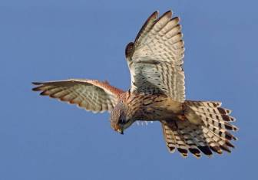
The state of the Kestrel population has given rise to increasing concern in recent years; in response the Raptor Study Group and the Shropshire Ringing Group have begun a county-wide programme of nest monitoring. Nest boxes are being erected in areas of suitable habitat, such as rough grassland, heath and rushy areas, which have surviving Kestrel populations, in order to supplement scarce natural sites and gather data on breeding and productivity.
Kestrels bred for the sixth consecutive year at what is currently the only known nest in the Upper Clun, though the presence of undetected nests cannot be ruled out. Five young were ringed and are believed to have fledged successfully. There have been very few reports of Kestrel sightings during the breeding season in recent years, and none at previously-used sites. Kestrels sometimes turn up in the area during the autumn and winter: some will be wintering birds from elsewhere in the country or from the continent, but where they are young birds dispersing from their natal sites there is potential for them to settle locally.
Please report Kestrel sightings to Michelle Frater,
via the Group’s email address
UCCWG@ShropsCWGs.org.uk.
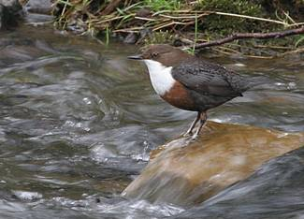
DIPPER
The stony, fast-flowing headwaters of the River Clun, including the River Unk and the Folly Brook, are a County stronghold for this species. Dipper survival and breeding success is closely linked to water quality; the health of the Dipper population, assessed by nest monitoring, ringing, and trapping or re-sighting ringed adults, is an important indicator of the health of the river environment.
Nests are located directly above flowing water; natural sites are used, but man-made structures are preferred where available, and Dippers take readily to nest boxes. With landowners' permission, specially-designed nest boxes have been installed under bridges in the Upper Clun to increase nesting opportunities and breeding success, and facilitate population monitoring.
There are over 30 nest boxes, which were initially funded and installed by UCCWG, but they are now monitored on behalf of the Group by Michelle Frater, and maintained by Tony Cross of the mid-Wales Ring Group, who rings almost all the chicks in them each year, and colour-rings adults whenever possible.
2025 Monitoring Results
- 24 sites were monitored, the great majority nest boxes under bridges
- ten were unoccupied or used by other species
- nests were attempted but abandoned at four, and clutches laid at ten
- 30 chicks were ringed; chicks that reach ringing age are likely to fledge and at two nests fledged young were detected; one further uncounted brood fledged
- two pairs produced second broods; both were successful, one pair raising nine chicks to ringing age in the season
- colour-rings on 13 breeding adults were read

Please report Dipper sightings to Michelle Frater,
via the Group’s email address
UCCWG@ShropsCWGs.org.uk.

Tony Cross has been monitoring Dippers in the Teme catchment since 1987, ringing chicks at nest sites and counting birds at winter roosts. Colour-ringing of adults started in 2011, and since then as many colour-rings as possible have been read during the breeding season and at roosts, giving an important measure of adult productivity and survival. The oldest dipper found so far in the Upper Clun was a male last recorded just 20 days short of eight years old; the national longevity record is 8 years 9 months.
Annual reports of this project, Dippers in the River Teme Catchment, were produced between 2007 and 2013.

